Eastern Union Bank



Submitted by:
Waleed Sarfraz 2023-CS-102

Supervised by:
Ma’am Maida Shahid

Department of Computer Science
University of Engineering and Technology Lahore Pakistan

Table of Contents
❖ About Eastern Union Bank: 6
➢ Contribution toward CS: 6
➢ Why Eastern Union Bank: 6
❖ User Types on Eastern Union Bank: 6
i. Admin: 7
ii. Manager: 7
iii. Employee: 7
iv. User: 7
❖ Functional Requirements of Eastern Union Bank: 7
❖ Wireframe of Eastern Union Bank: 9
➢ Basic (For All types of Users): 10
• Startup Animation: 10
• Startup Interface: 10
•Sign-up Menu: 11
•Sign-in Menu: 11
➢ User Type (Admin): 12
• Admin Menu: 12
• Withdraw money: 12
•Check balance: 13
• Money Transfer: 13
• Deposit Money: 14
• Pay Bills Menu: 14
• Electricity Bill: 15
• Gas Bill: 15
• Water Bill: 16
• Update Password: 16
• Delete Account: 17
• View Accounts: 17
• View Feedbacks: 18
• Add Reservoir: 18
• Available Reservoirs: 19
➢ User Type (Manager): 19
• Manager Menu: 19
• Check Balance: 20
• Deposit Money: 20
• Withdraw Money: 21
• Money Transfer: 21
• Update Password: 22
• View Feedbacks: 22
• Add Accounts: 23
• View Feedbacks: 23
• Add Accounts: 24
• View Reservoir: 24
• Pay Bills Menu: 25
• Electricity Bill: 25
• Gas Bill: 26
• Water Bill: 26
• Delete Account: 27
• See the list of employees: 27
• Decide Employee’s salary: 28
• Total expenditure on employees: 28
➢ User Type (Employee): 29
• Employee Menu: 29
• Withdraw Money: 29
• Check Balance: 30
• Money Transfer: 30
• Pay Bills Menu: 31
• Electricity Bill Menu: 31
• Gas Bill Menu: 32
• Water Bill Menu: 32
• Update Password: 33
• View Accounts: 33
• Delete Account: 34
• View Feedbacks: 34
➢ User Type (User): 35
• User Menu: 35
• Withdraw money: 35
•Check Balance: 36
• Money Transfer: 36
• Update Password: 37
• Deposit Amount: 37
• Deposit Amount in Dollars: 38
• Enter Feedback: 38
• Update Password: 39
• Home Loan: 39
• Student Loan: 40
• Debt Consolidation Loan: 40
• See Your Aggregate Debt: 41
• Pay your Debt: 41
• Pay Bills Menu: 42
• Electricity Bill: 42
• Gas Bill: 43
• Water Bill: 43
❖ Data Structure: 44
❖ Function Prototypes: 44
• Weakness: 46
❖ Future Directions: 47

Table of Figures

Figure 1. Startup Interface 10
Figure 2. Startup Menu 10
Figure 3. Sign up Menu 11
Figure 4. Sign-in Menu 11
Figure 5. Admin Menu 12
Figure 6. Withdraw money 12
Figure 7. Check Balance 13
Figure 8. Money Transfer 14
Figure 9. Deposit Money 14
Figure 10. Pay Bills Menu 15
Figure 11. Electricity Bill Menu 15
Figure 12. Gas Bill Menu 16
Figure 13. Water Bill Menu 16
Figure 14. Update Password 17
Figure 15. Delete Account 17
Figure 16. View Accounts 18
Figure 17. View feedbacks 18
Figure 18. Add Reservoir 19
Figure 19. Available Reservoir 19
Figure 20. Manager Menu 20
Figure 21. Check Balance 20
Figure 22. Deposit Money 21
Figure 23. Withdraw Money 21
Figure 24. Money Transfer 22
Figure 25. Update Password 22
Figure 26. View Feedbacks 23
Figure 27. Add Account 23
Figure 28. View Reservoir 24
Figure 29. Add Accounts 24
Figure 30. View Reservoir 25
Figure 31. Pay Bills Menu 25
Figure 32. Electricity Bill Menu 26
Figure 33. Gas Bill Menu 26
Figure 34. Water Bill Menu 27
Figure 35. Delete Account 27
Figure 36. See the list of employees 28
Figure 37. Decide Employee’s salary 28
Figure 38. Total Expenditure on employees 29
Figure 39. Employee Menu 29
Figure 40. Withdraw Money 30
Figure 41. Check Balance 30
Figure 42. Money Transfer 30
Figure 43. Pay Bills Menu 31
Figure 44. Electricity Bill Menu 31
Figure 45. Gas Bill Menu 32
Figure 46. Water Bill Menu 32
Figure 47. Update Password 33
Figure 48. View Accounts 33
Figure 49. Delete Account 34
Figure 50. View Feedbacks 34
Figure 51. User Menu 35
Figure 52. Withdraw money 35
Figure 53. Check Balance 36
Figure 54. Money Transfer 36
Figure 55. Update Password 37
Figure 56. Deposit Amount 37
Figure 57. Deposit Amount in Dollars 38
Figure 58. Enter Feedback 38
Figure 59. Loan Menu 39
Figure 60. Home Loan 39
Figure 61. Student Loan 40
Figure 62. Debt Consolidation Loan 40
Figure 63. See your aggregate debt 41
Figure 64. Pay your debt 41
Figure 65. Pay Bills Menu 42
Figure 66. Electricity Bill Menu 42
Figure 67. Gas Bill Menu 43
Figure 68. Water Bill Menu 43

About Eastern Union Bank:
Welcome to Eastern Union Bank, your go-to financial companion offering a spectrum of features for a seamless banking experience. From effortless fund transfers to real-time loan borrowing, our app combines simplicity with advanced security measures. Enjoy the convenience of bill payments, loan payments, and personalized insights, all crafted to elevate your financial well-being and banking experience.

Contribution toward CS:
EUB brings the process of automation into management of data in the banks. The process of data handling is done in an organized way so that data can be manipulated and used in an orderly fashioned way. Also, EUB helps contribute towards analyzing statistics of the bankers.

Why Eastern Union Bank:
Eastern Union Bank is a user-friendly app designed for the ease of the users. The users don’t need any special knowledge or read a full diary of manual to use this app. Anyone can use this app for its simple but efficient functions and add ease and peace to their life through almost struggle-free online banking.

User Types on Eastern Union Bank:
EUB provides different access for different type of users. The users are divided into three categories, admin, employee, and user. Each user type has access to different types of commands related to their need and requirements. Each user has to tell its role while signing up for the application and their data is stored for further authentication and login.
The hierarchy and functionality of user types is as under: -

i. Admin:
Admin is the owner of the bank. He has access to the reservoir of the bank. He can see other users of his bank; view feedbacks of his users and add to the reservoir of the bank. He also has his own bank account and manage his own finance.

ii. Manager:
Manager has the privilege of managing employees and other important functions of the bank. He has access to the list of employees, can manage their salaries, view feedbacks and also, pay his bills. He can also exclude employees and see the list of debtors.

iii. Employee:
Employee can also delete or add accounts as it is the normal practice of any bank. Also, he can update his password and has access to the facilities of transferring money and adding and withdrawing money from his account. He can also view the feedback given by the users. He can also pay his bills.

iv. User:
User has access to his transaction history and he can also change the password of his Bank account. He can also apply for loan. He can check his balance, deposit money, withdraw money and can also pay his bills using his bank account. Moreover, he can also give the feedback to the banking system at Eastern Union Bank.

Functional Requirements of Eastern Union Bank:

Some of the functional requirements expected from Eastern Union Bank are as under:

User Type | Required Function to be Performed | Result of Action Performed
ADMIN | Withdraw Money | Withdraws money from admin’s account.
 | Check Balance | Shows the balance of admin’s account.
 | Money Transfer | Transfers money from admin’s account.
 | Update Password | Updates the password of the admin’s account.
 | Delete Accounts | Allows admin to delete anyone’s account, given he enters valid credentials.
 | View Accounts | Shows the list of all the users of the app.
 | View Feedbacks | Shows all the feedbacks given by the users.
 | Add reservoir | Adds money to the reservoir of the bank.
 | See available reservoir | Shows the available reservoir of the bank.
 | Check Balance | Shows the balance of admin’s account.
 | Deposit money | Allows manager to add money in his account.
 | Withdraw Money | Withdraws money from admin’s account.
 | Money Transfer | Transfers money from admin’s account.
 | Update Password | Updates the password of the admin’s account.
 | View Feedbacks | Shows all the feedbacks given by the users.
 | View reservoir | Shows the available reservoir of the bank.
 | Add Account | Allows manager to add accounts.
 | Pay Bills | Allows manager to pay his own bills.
 | Decide employee’s salary | Allows manager to decide the employee’s salary.
MANAGER | Delete Account. | Allows manager to delete users’ accounts, except that of admin.
 | See list of debtors. | Shows the manager the list of all the debtors.
 | Decide employee salary. | Allows the manager to decide employee’s salary.
 | Total Expenditure on employee. | Shows the aggregate of employees’ salaries.
 | Withdraw Money | Withdraws money from admin’s account.
 | Check Balance | Shows the balance of admin’s account.
 | Money Transfer | Transfers money from admin’s account.
 | Pay Bills | Allows manager to pay his own bills.
EMPLOYEE | Delete Account. | Allows manager to delete users’ accounts, except that of admin.
 | Update Password | Updates the password of the admin’s account.
 | View Accounts | Shows the list of all the users of the app.
 | View Feedbacks | Shows all the feedbacks given by the users.
 | Deposit amount in dollars | Allows user to deposit money in dollars.
 | Pay debt/ loan | Allows users to pay their loan/ debt.
 | Loan | Allows user to take three types of loan.
 | See aggregate debt | Users can see their total loan.
 | Deposit money | Allows manager to add money in his account.
 | Withdraw Money | Withdraws money from admin’s account.
 | Check Balance | Shows the balance of admin’s account.
USER | Enter Feedback | Allows user to enter feedback, which will be viewed by higher authorities later on.
 | Pay bills | Allows users to pay their electricity, water and gas bills.
 | Money transfer | Allows users to transfer money from their accounts to their wallets.
 | Update password | Allows users to update their passwords.

Wireframe of Eastern Union Bank:
The following is the wireframe of Eastern Union Bank displayed in
Command Line Interface:

Basic (For All types of Users):

• Startup Animation:
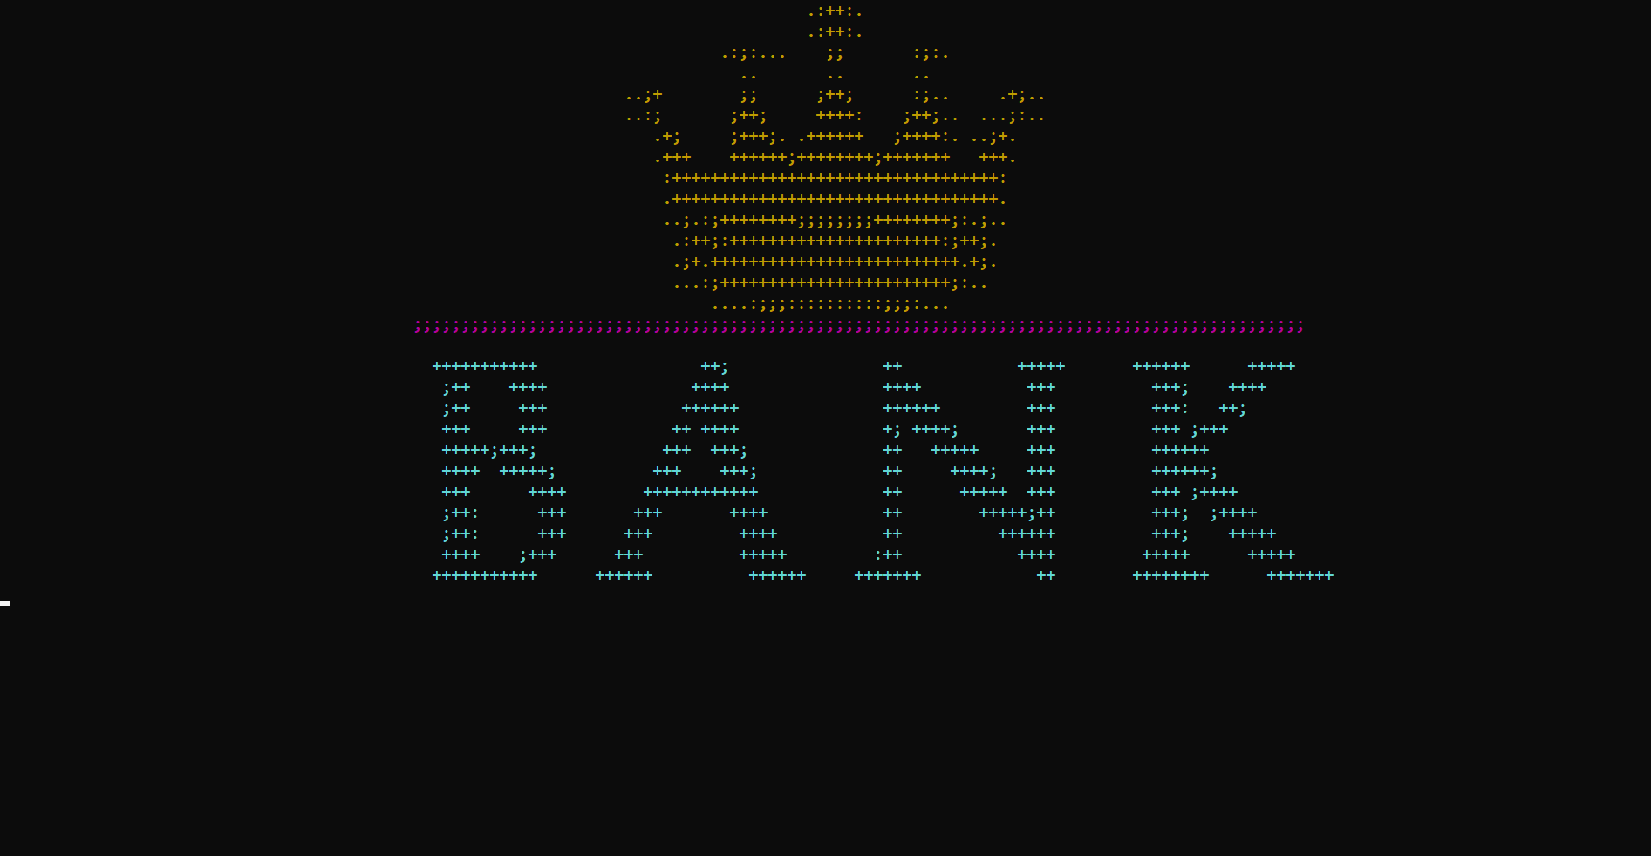
Figure 1. Startup Interface

• Startup Interface:

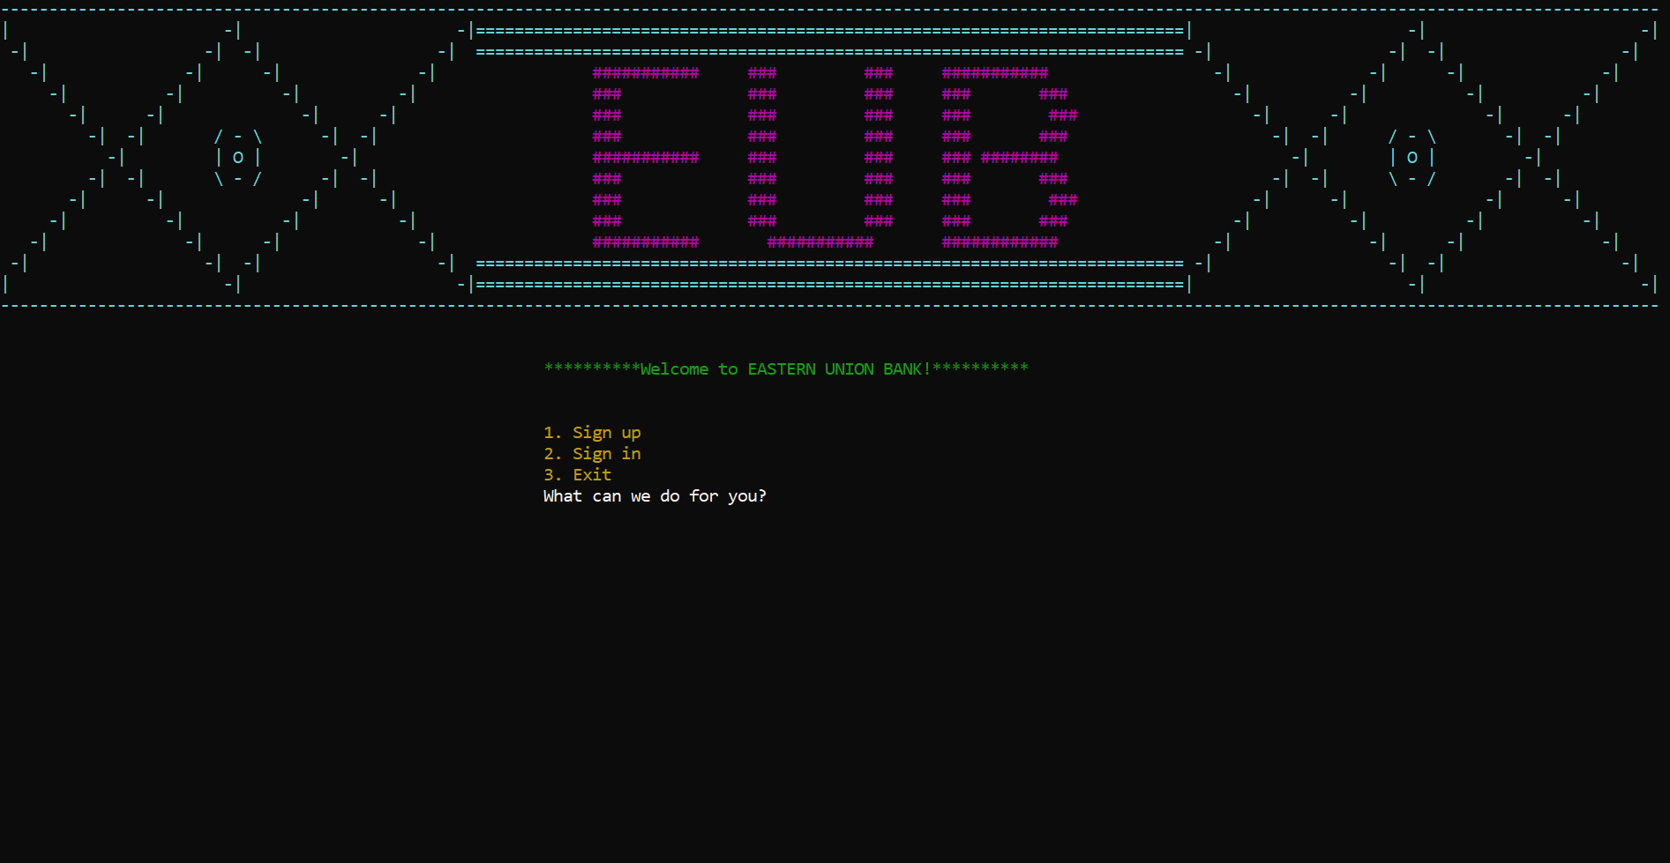

Figure 2. Startup Menu

•Sign-up Menu:

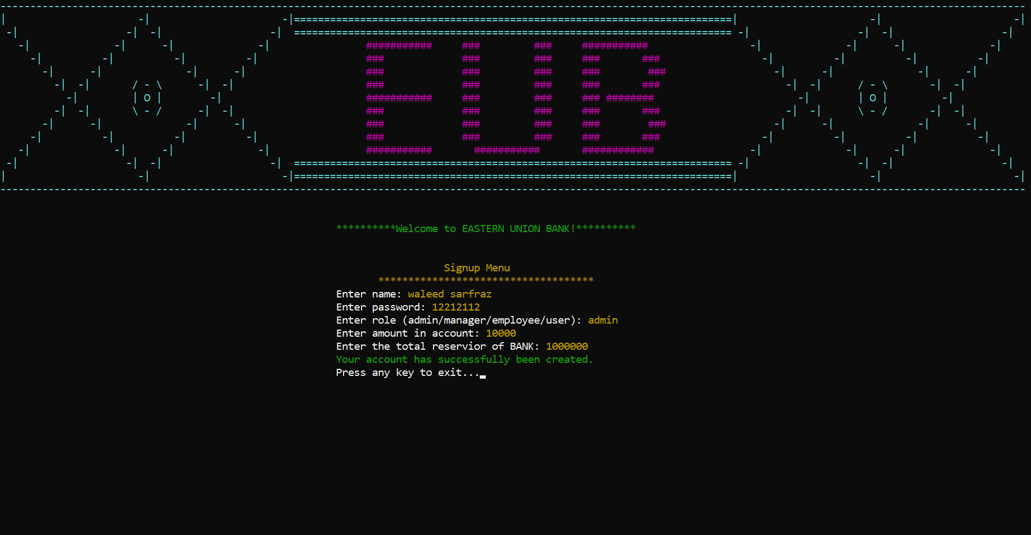

Figure 3. Sign up Menu

•Sign-in Menu:
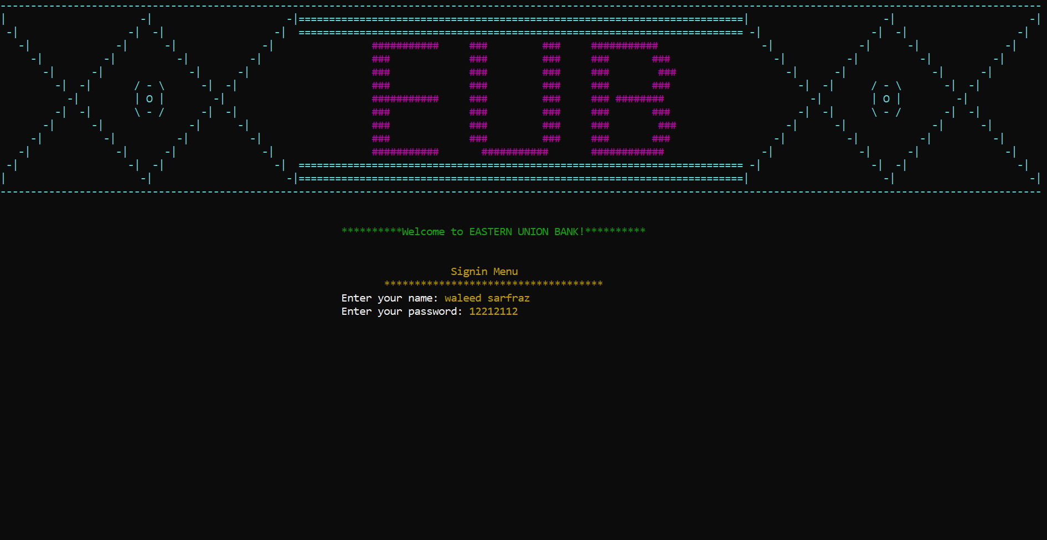

Figure 4. Sign-in Menu

User Type (Admin):

• Admin Menu:

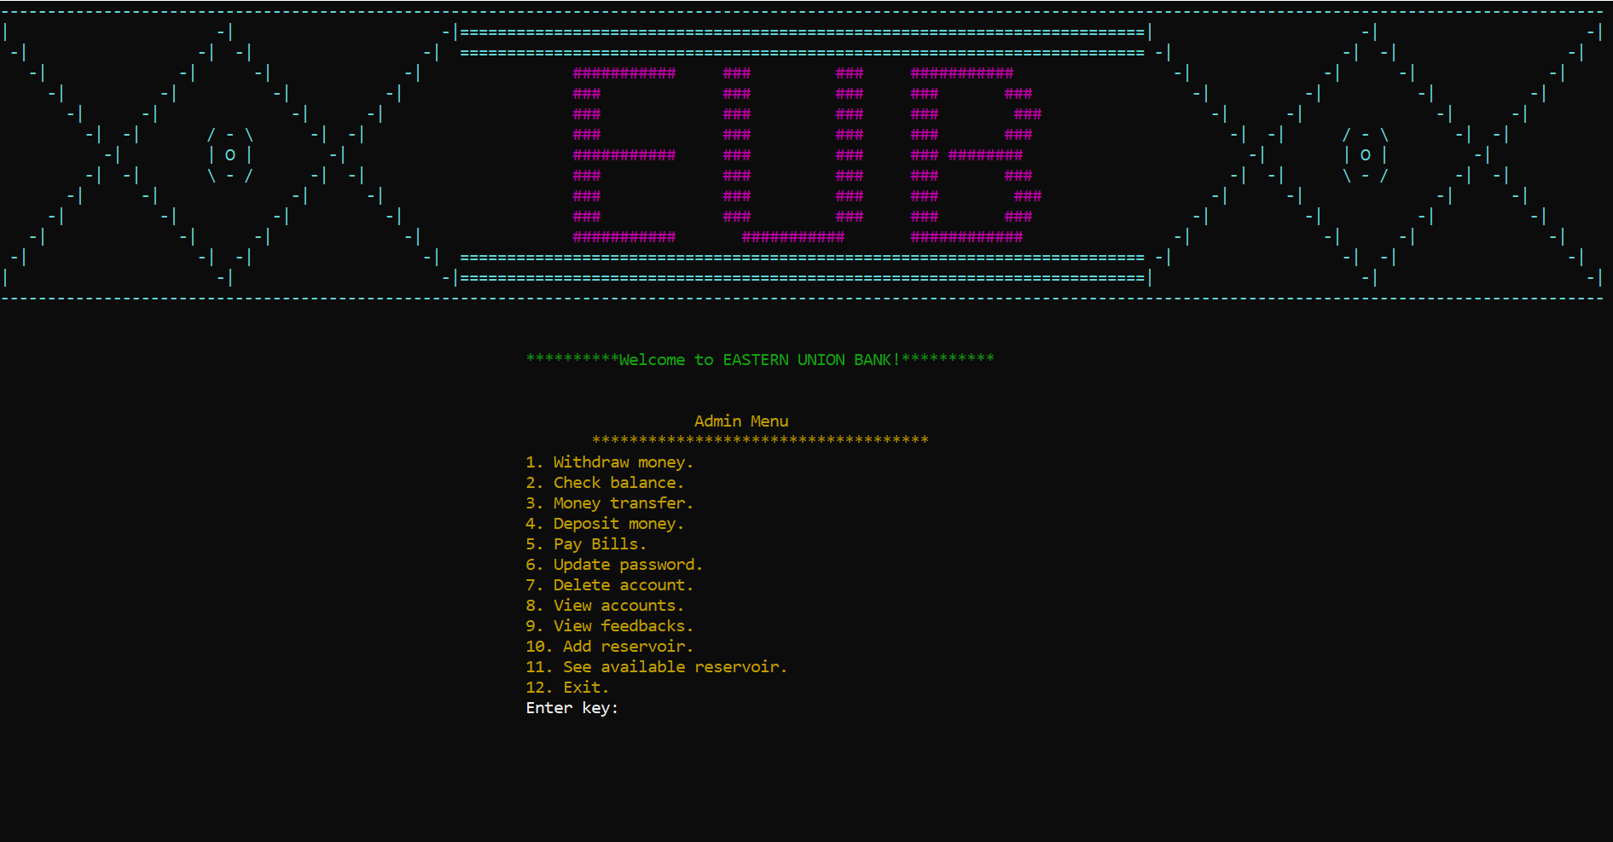

Figure 5. Admin Menu

• Withdraw money:

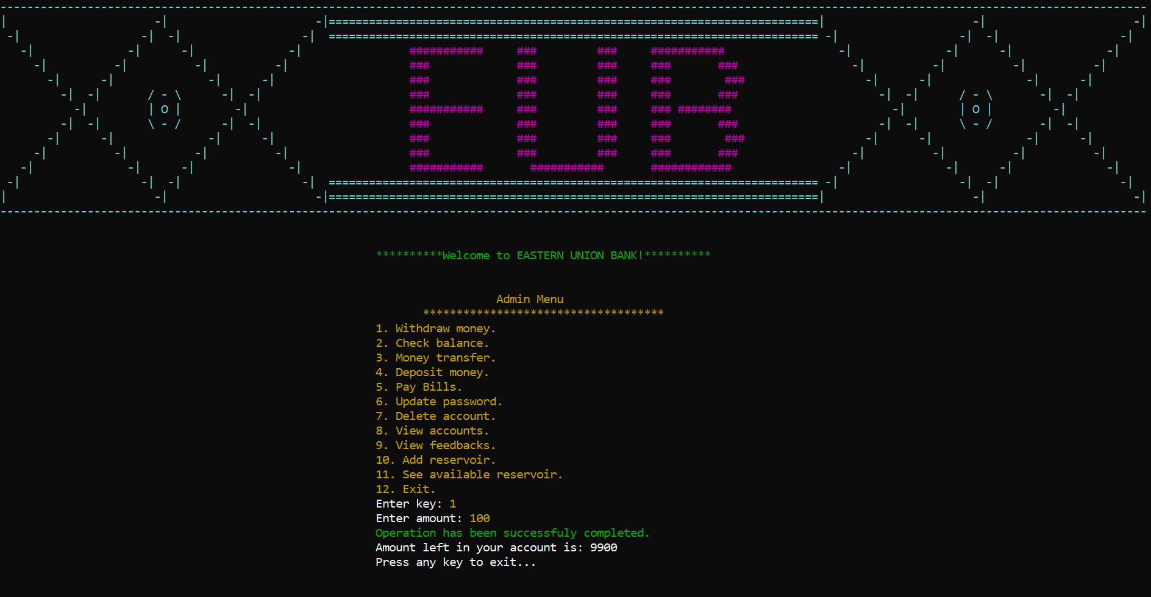

Figure 6. Withdraw money

•Check balance:

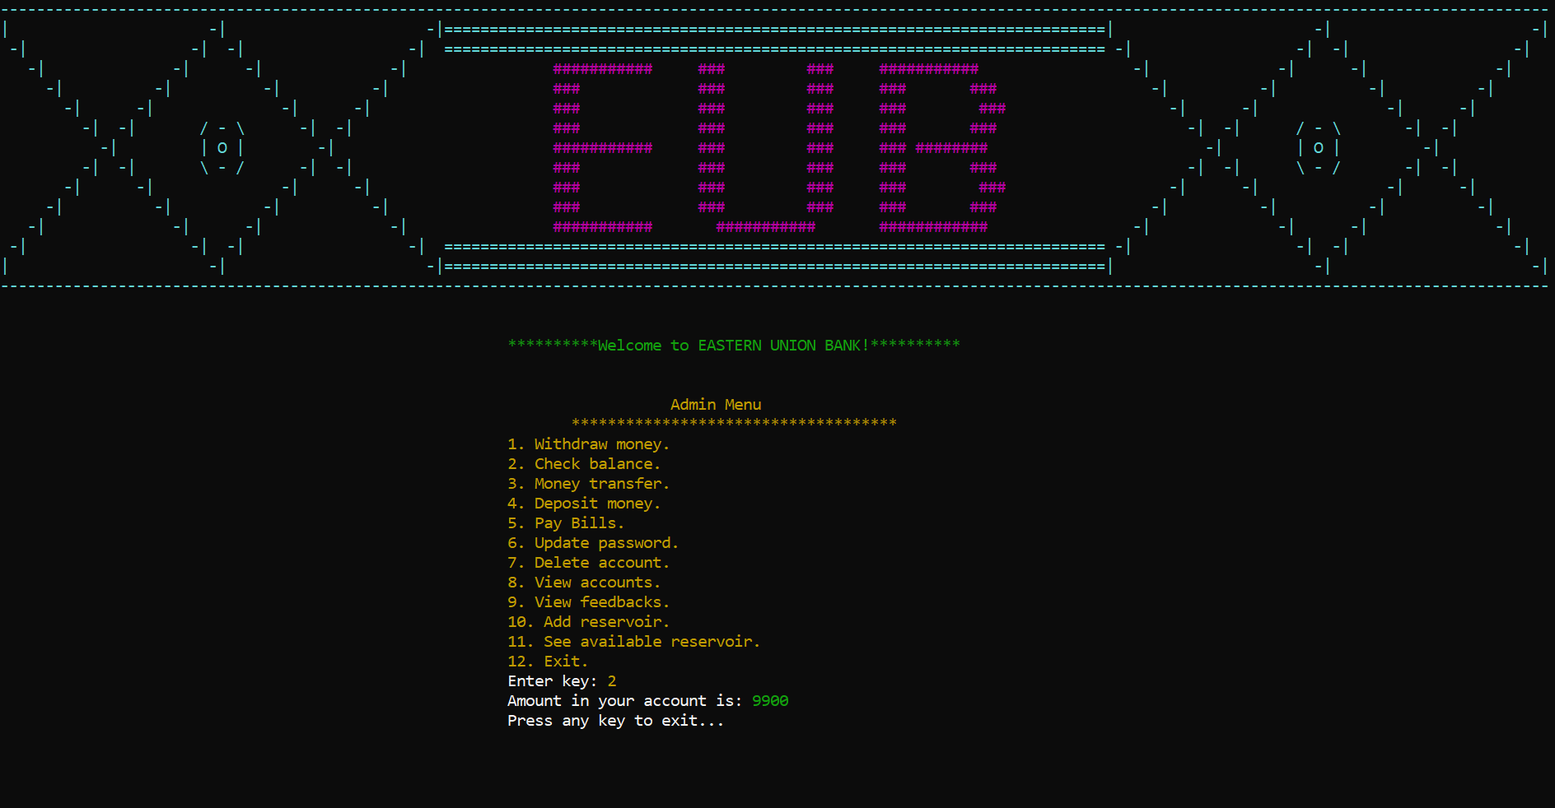

Figure 7. Check Balance

• Money Transfer:

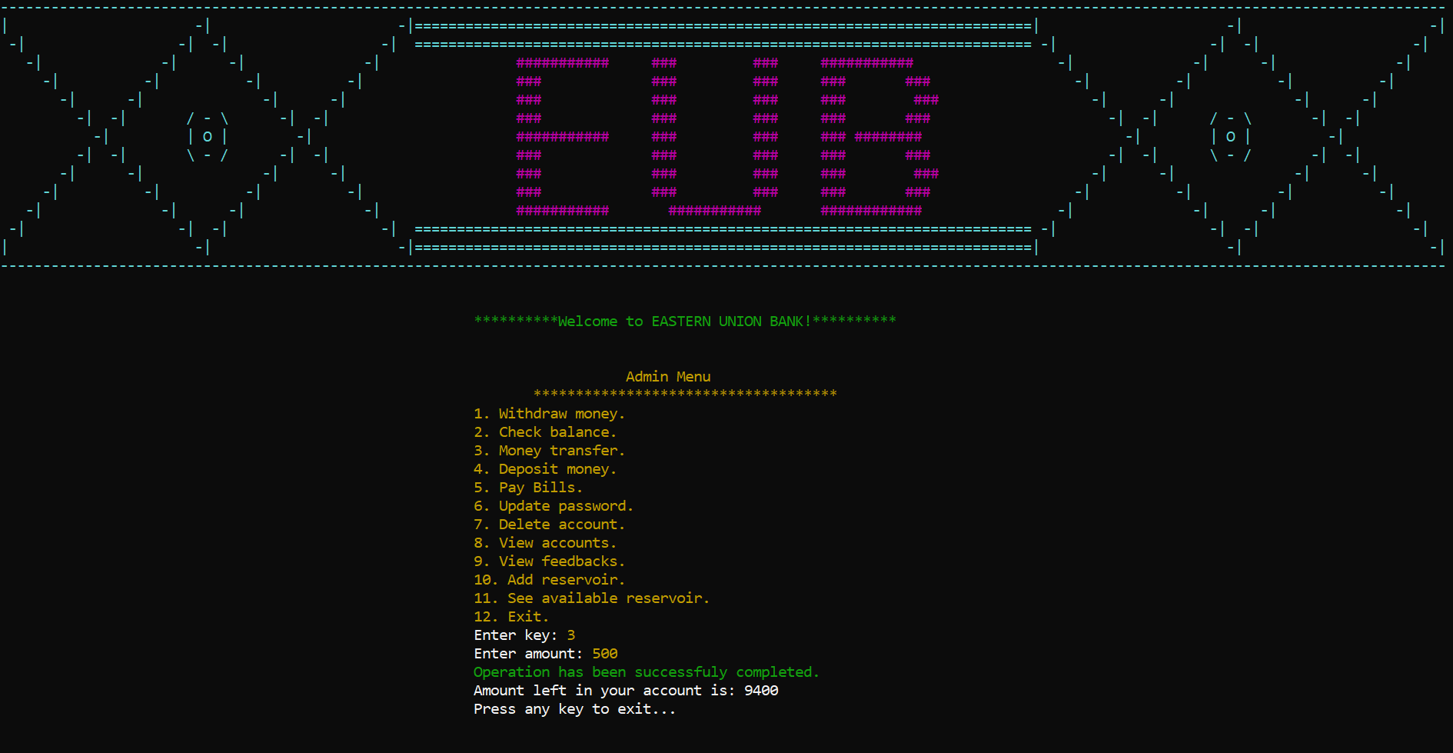

Figure 8. Money Transfer

• Deposit Money:

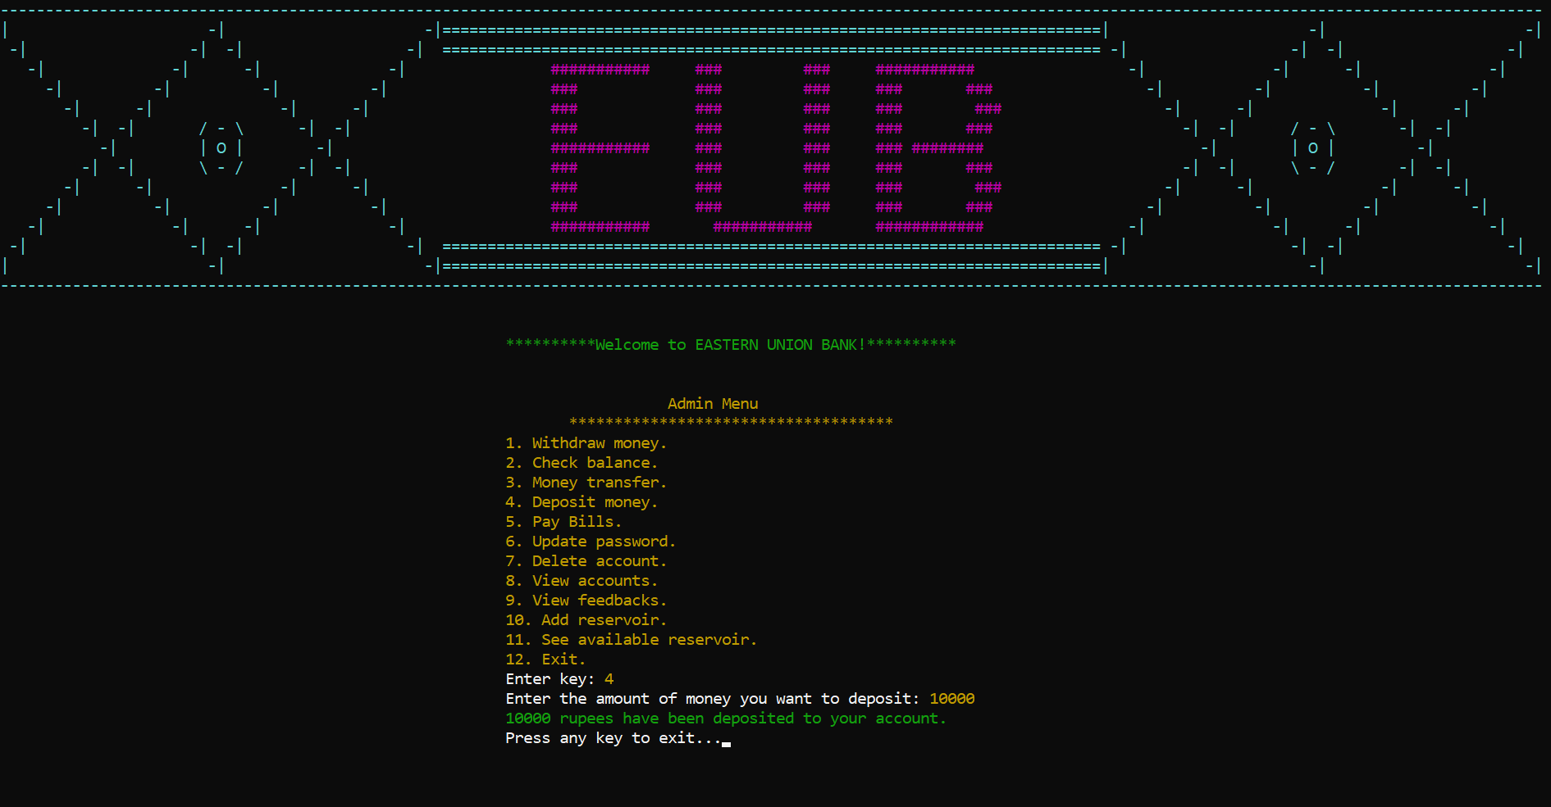

Figure 9. Deposit Money

• Pay Bills Menu:

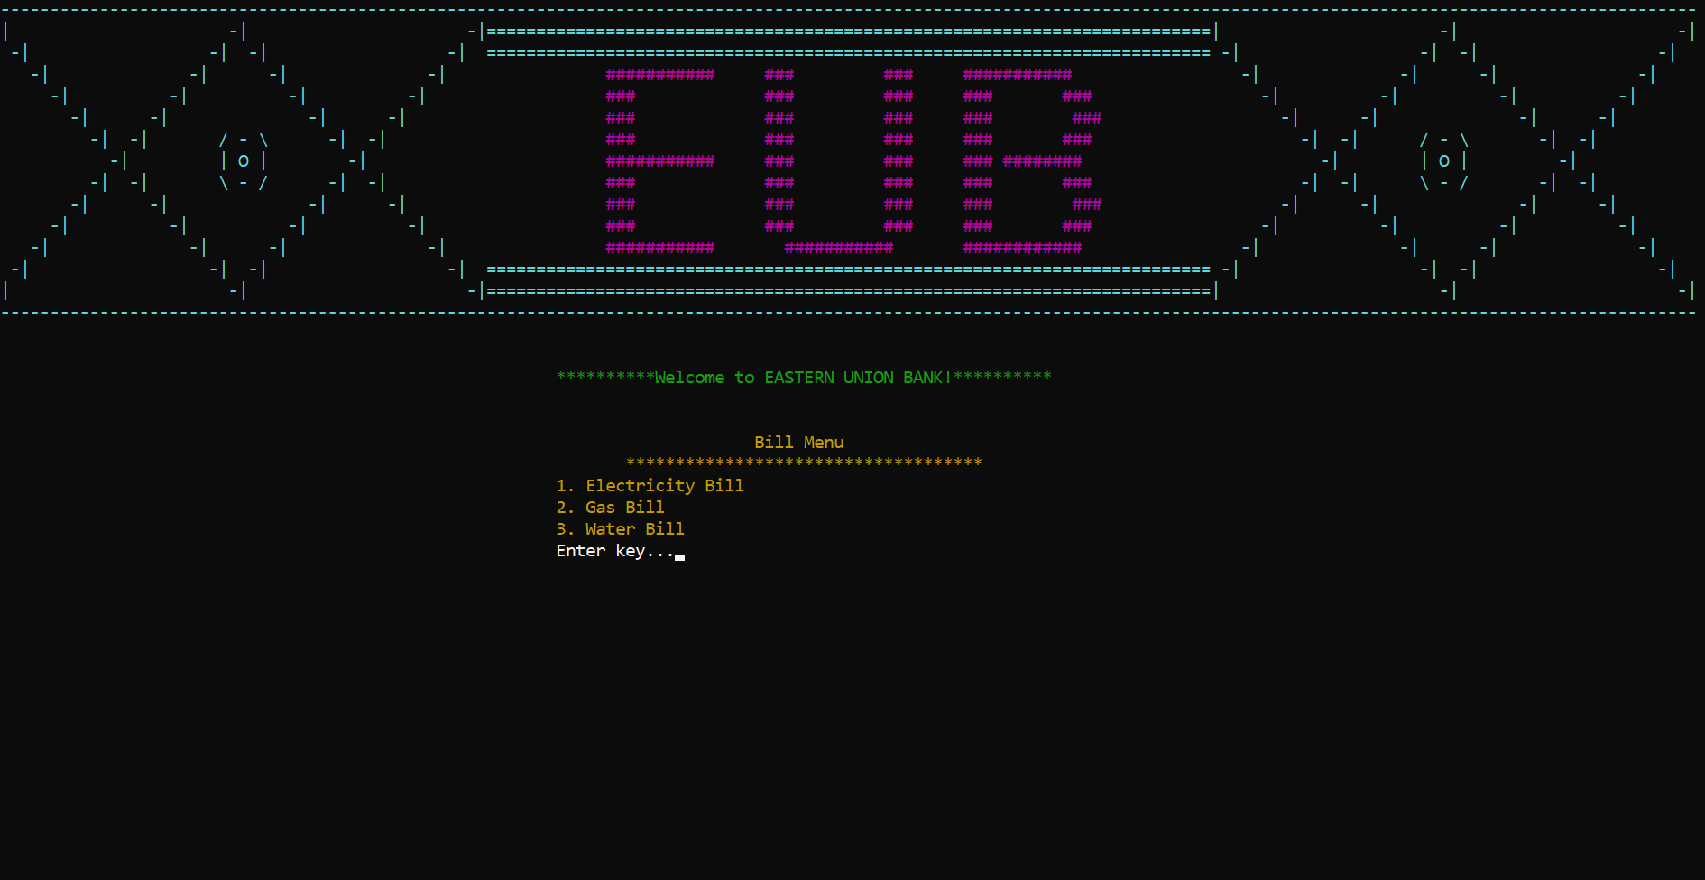

Figure 10. Pay Bills Menu

• Electricity Bill:

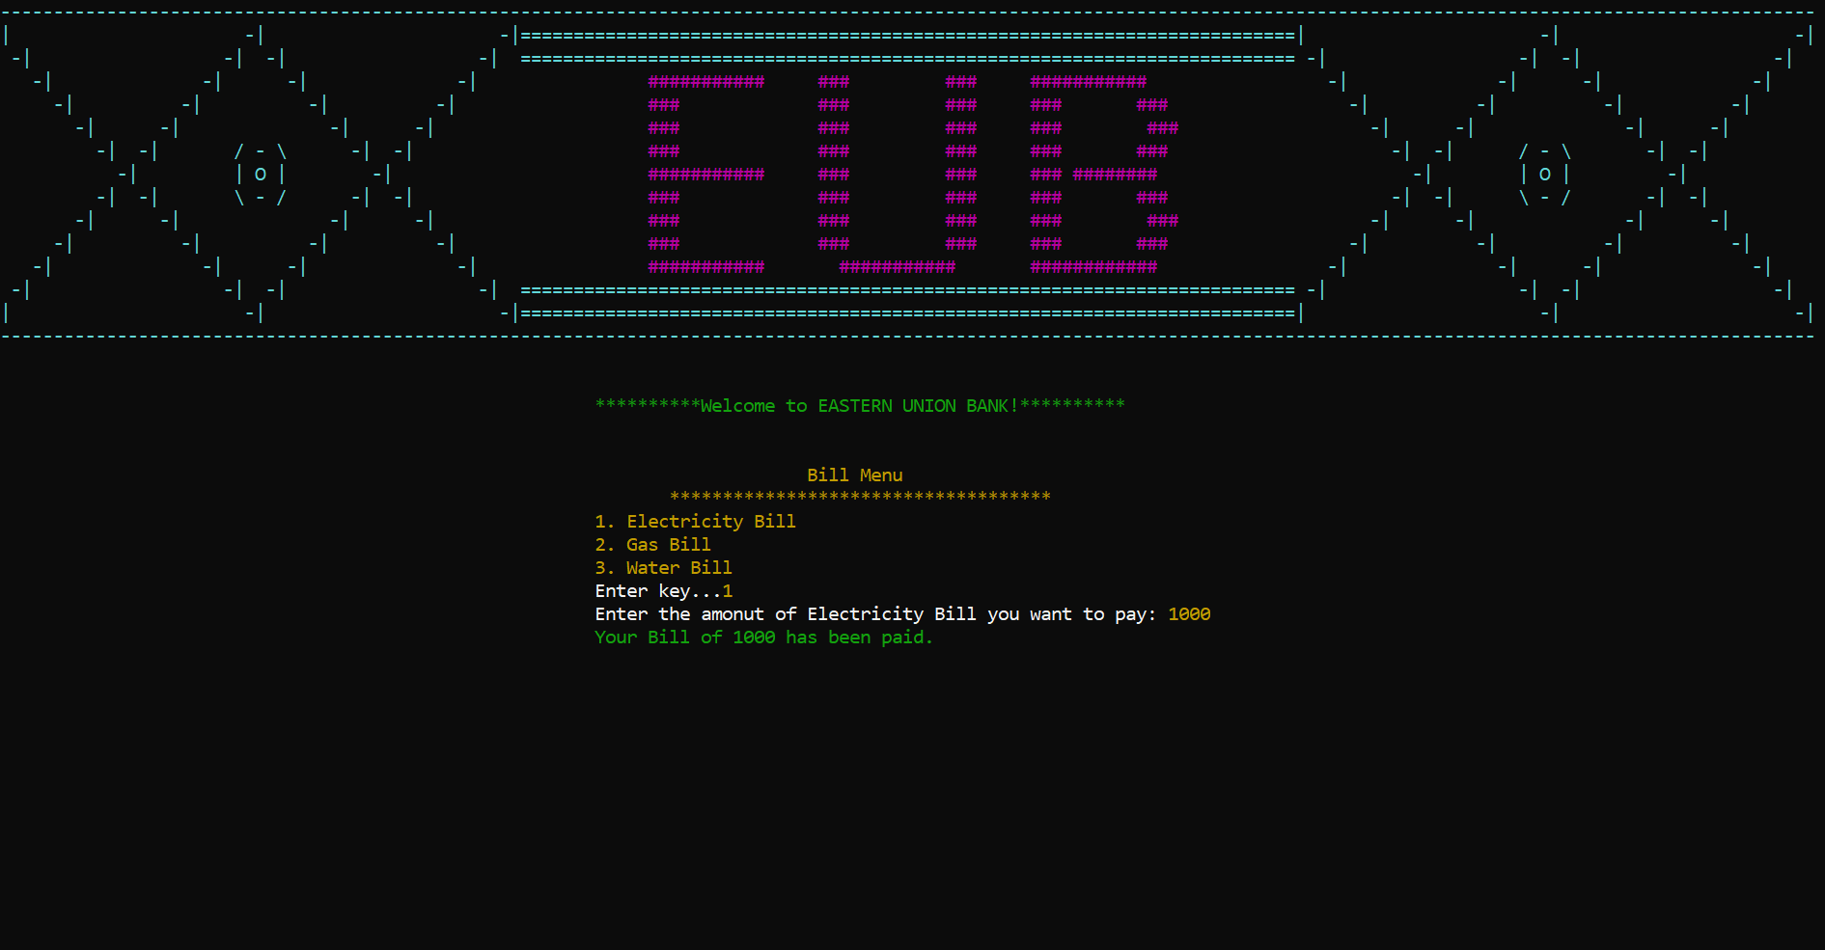

Figure 11. Electricity Bill Menu

• Gas Bill:

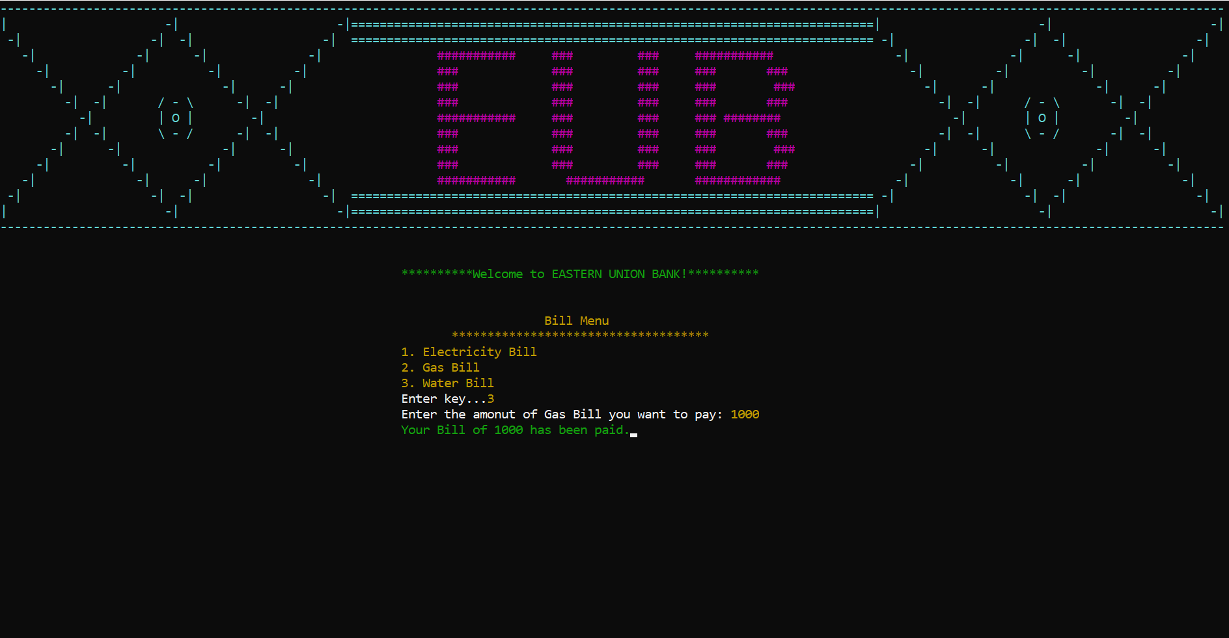

Figure 12. Gas Bill Menu

• Water Bill:

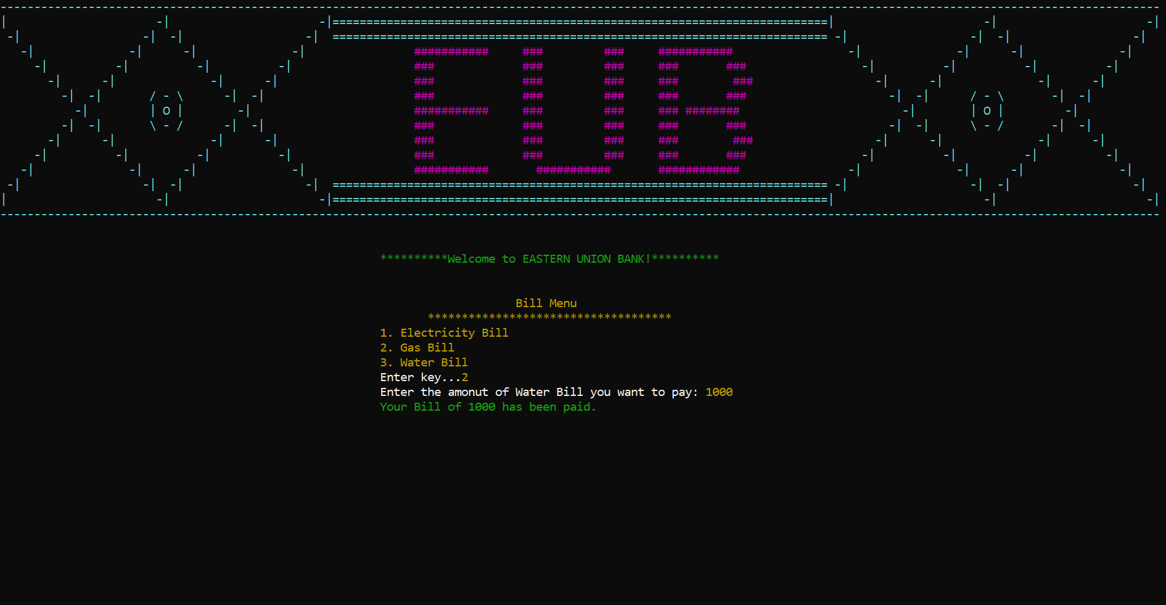

Figure 13. Water Bill Menu

• Update Password:

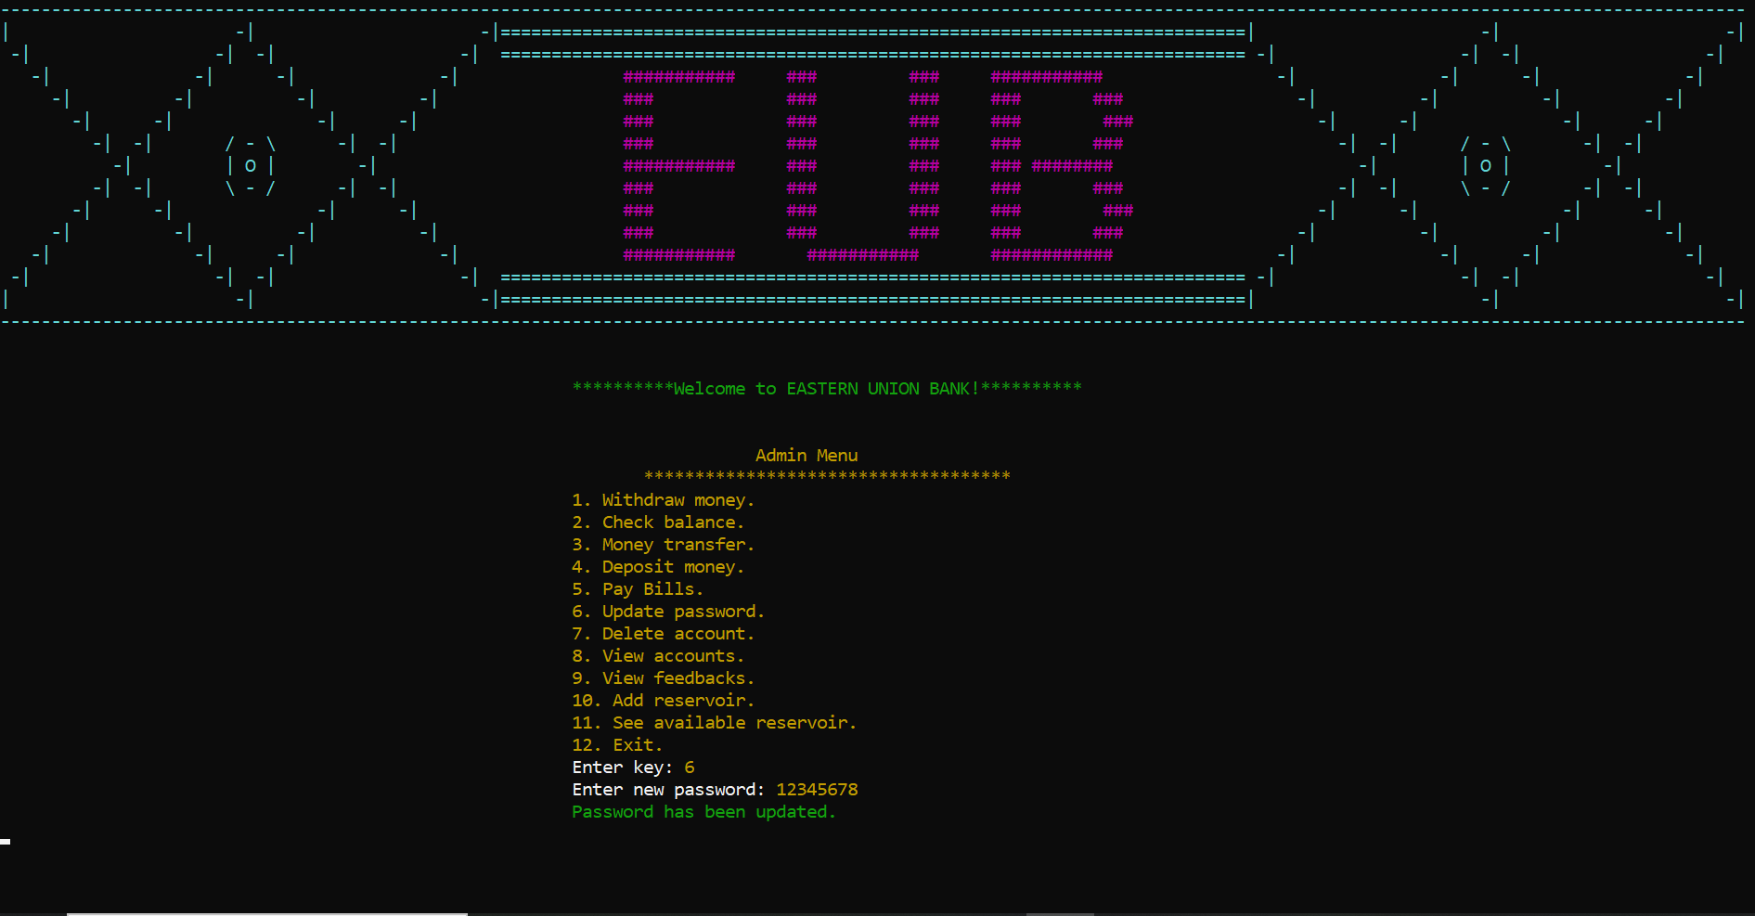

Figure 14. Update Password

• Delete Account:

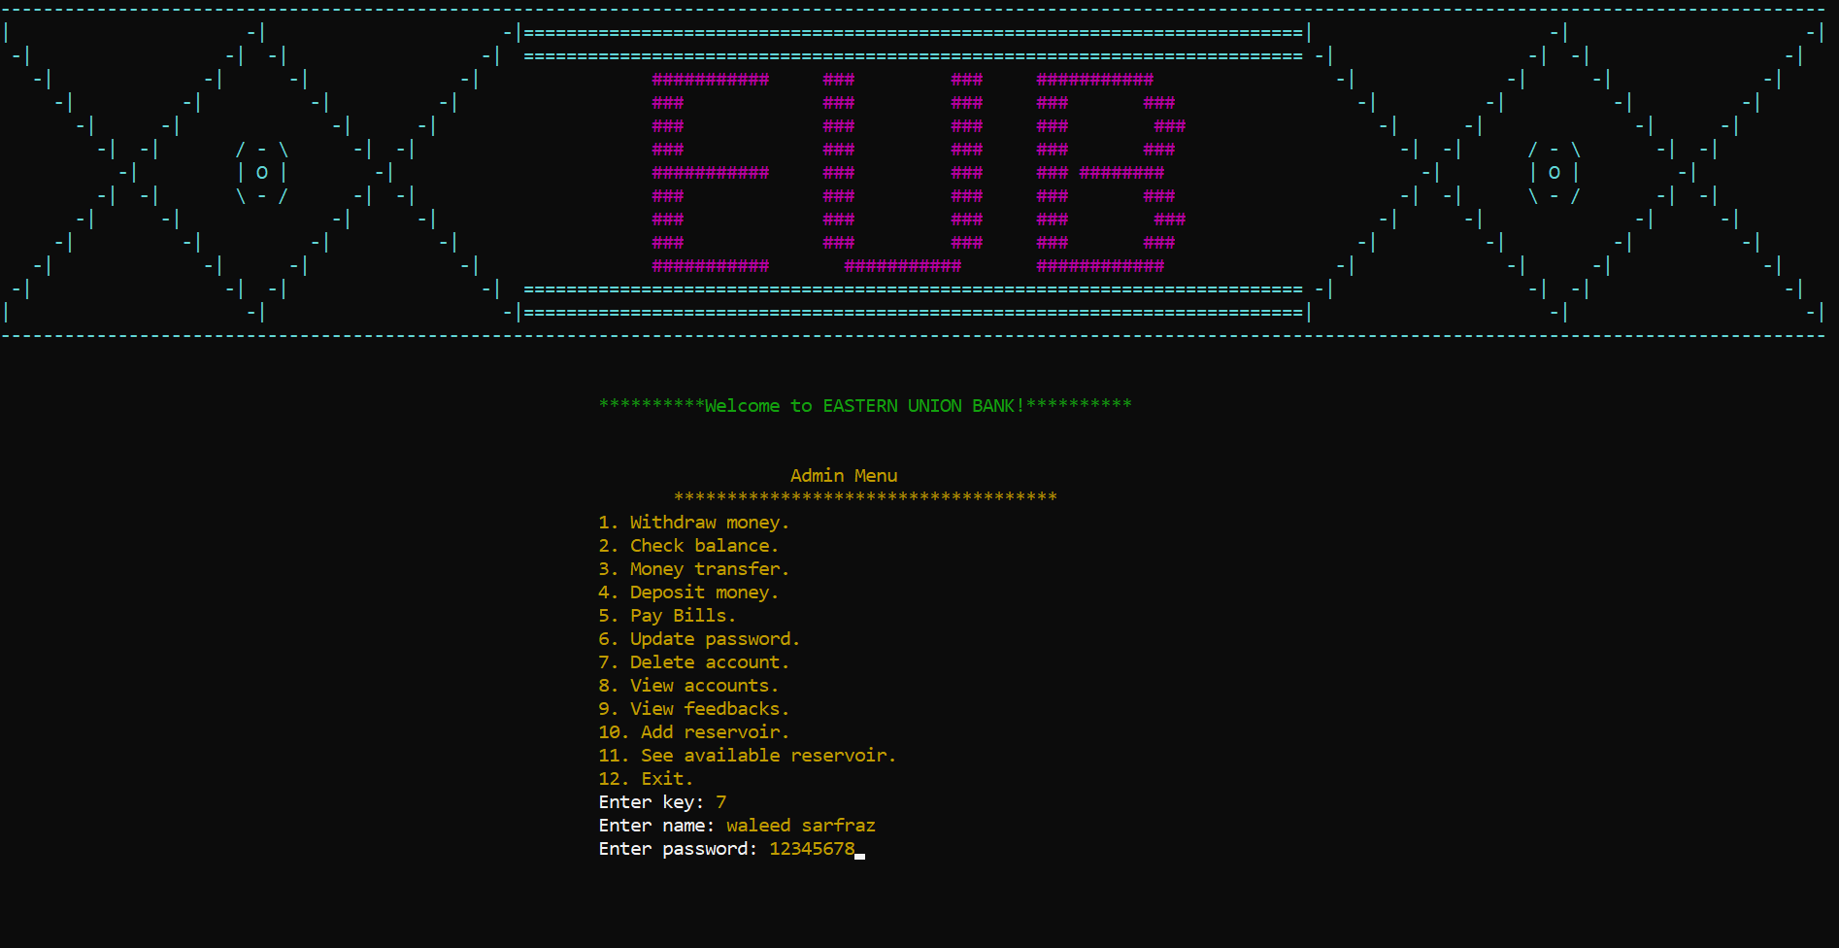

Figure 15. Delete Account

• View Accounts:

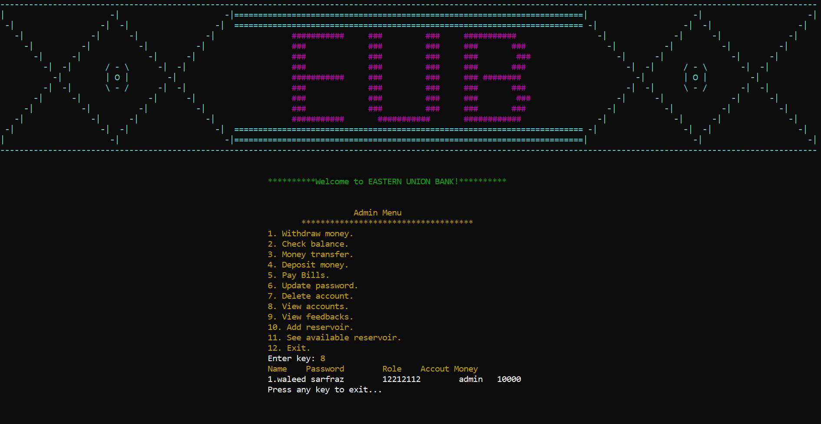

Figure 16. View Accounts

• View Feedbacks:
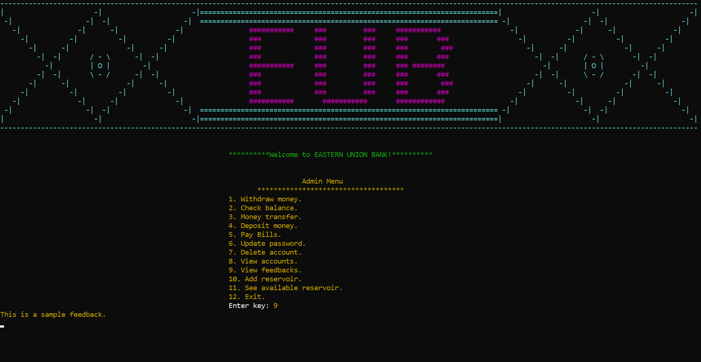

Figure 17. View feedbacks

• Add Reservoir:

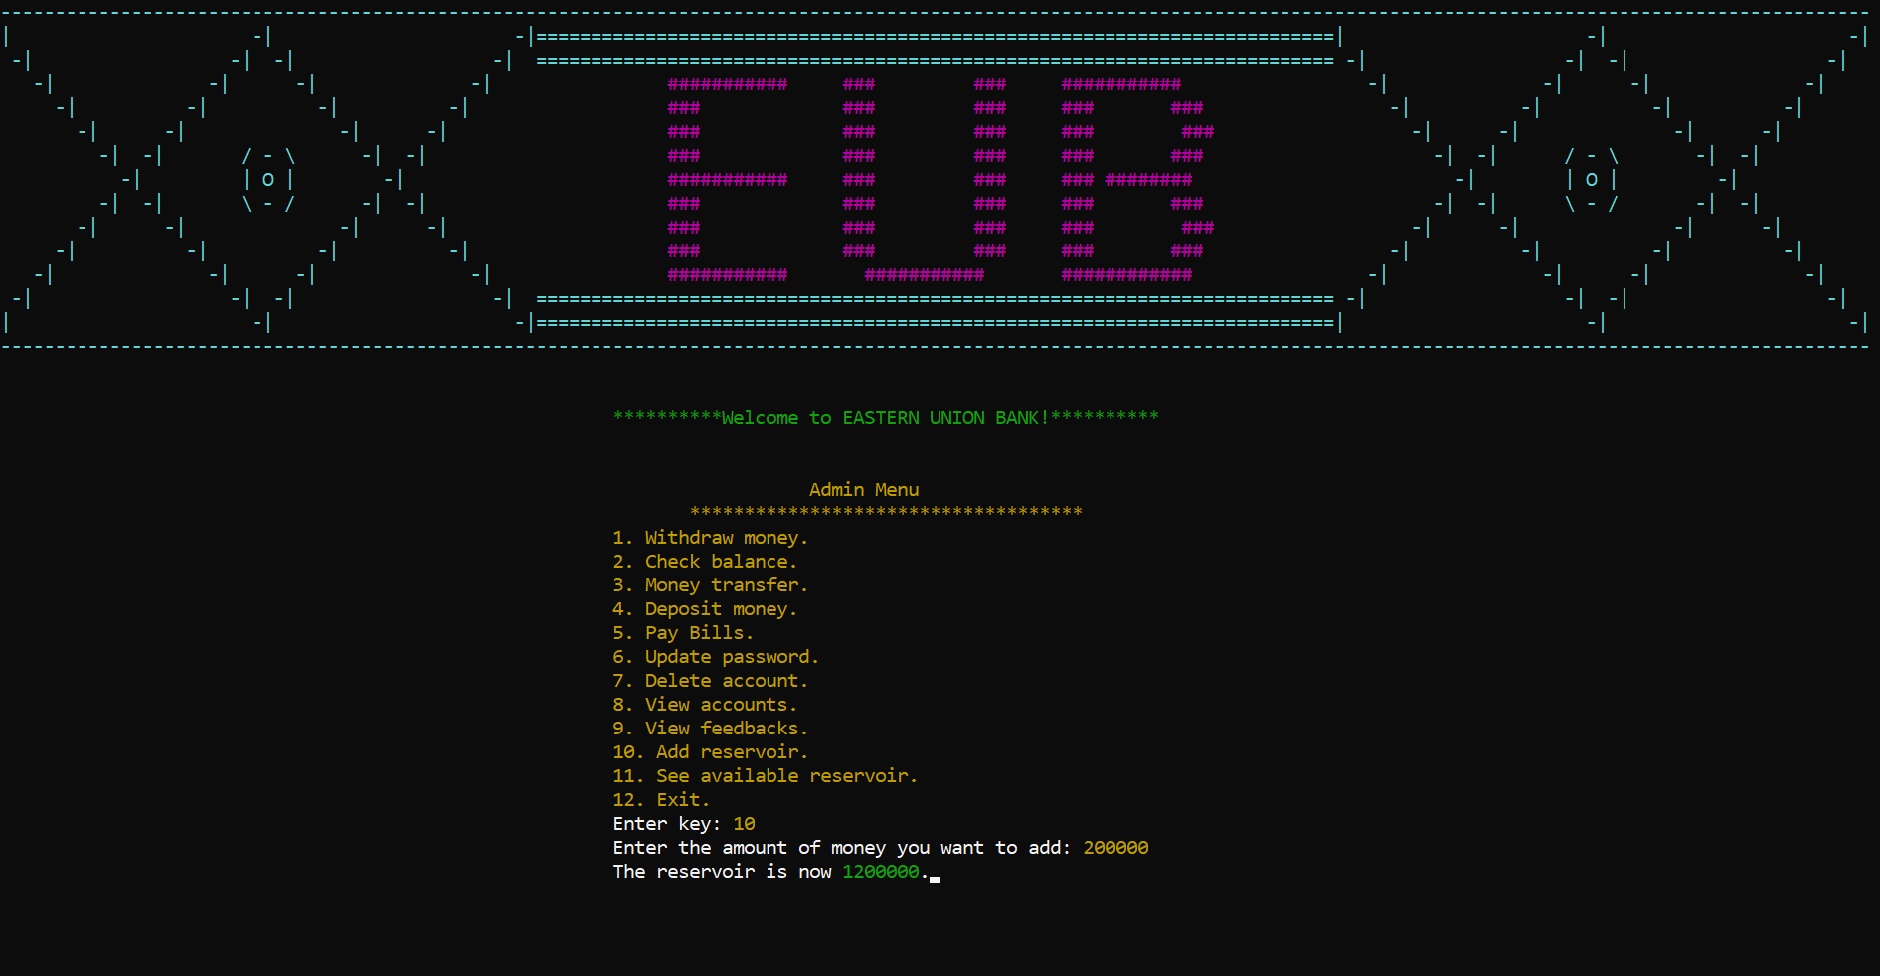

Figure 18. Add Reservoir

• Available Reservoirs:

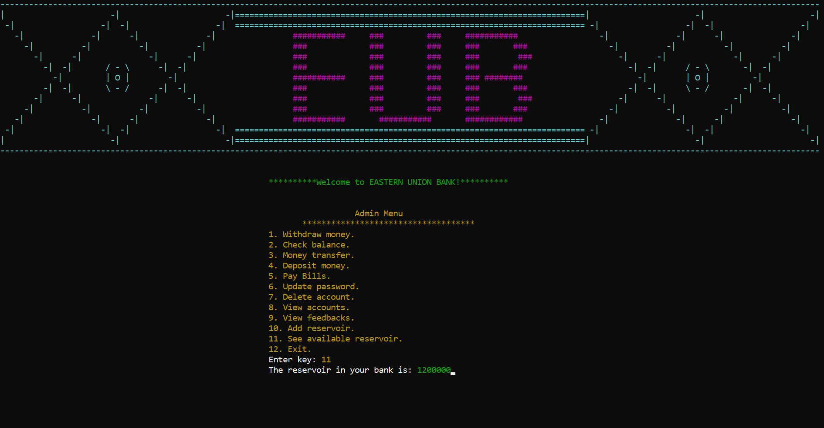

Figure 19. Available Reservoir

User Type (Manager):

• Manager Menu:

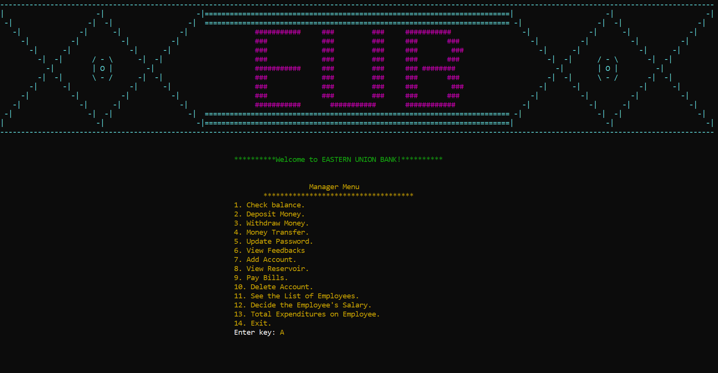

Figure 20. Manager Menu

• Check Balance:

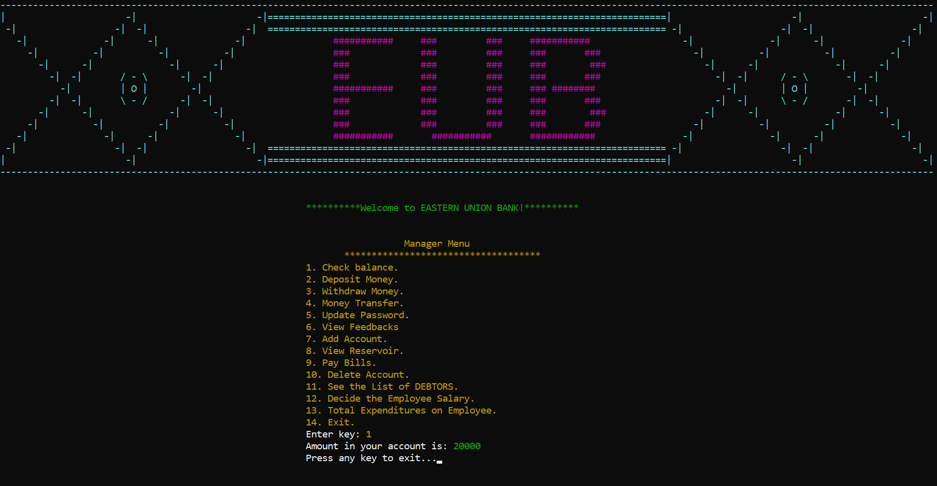

Figure 21. Check Balance

• Deposit Money:

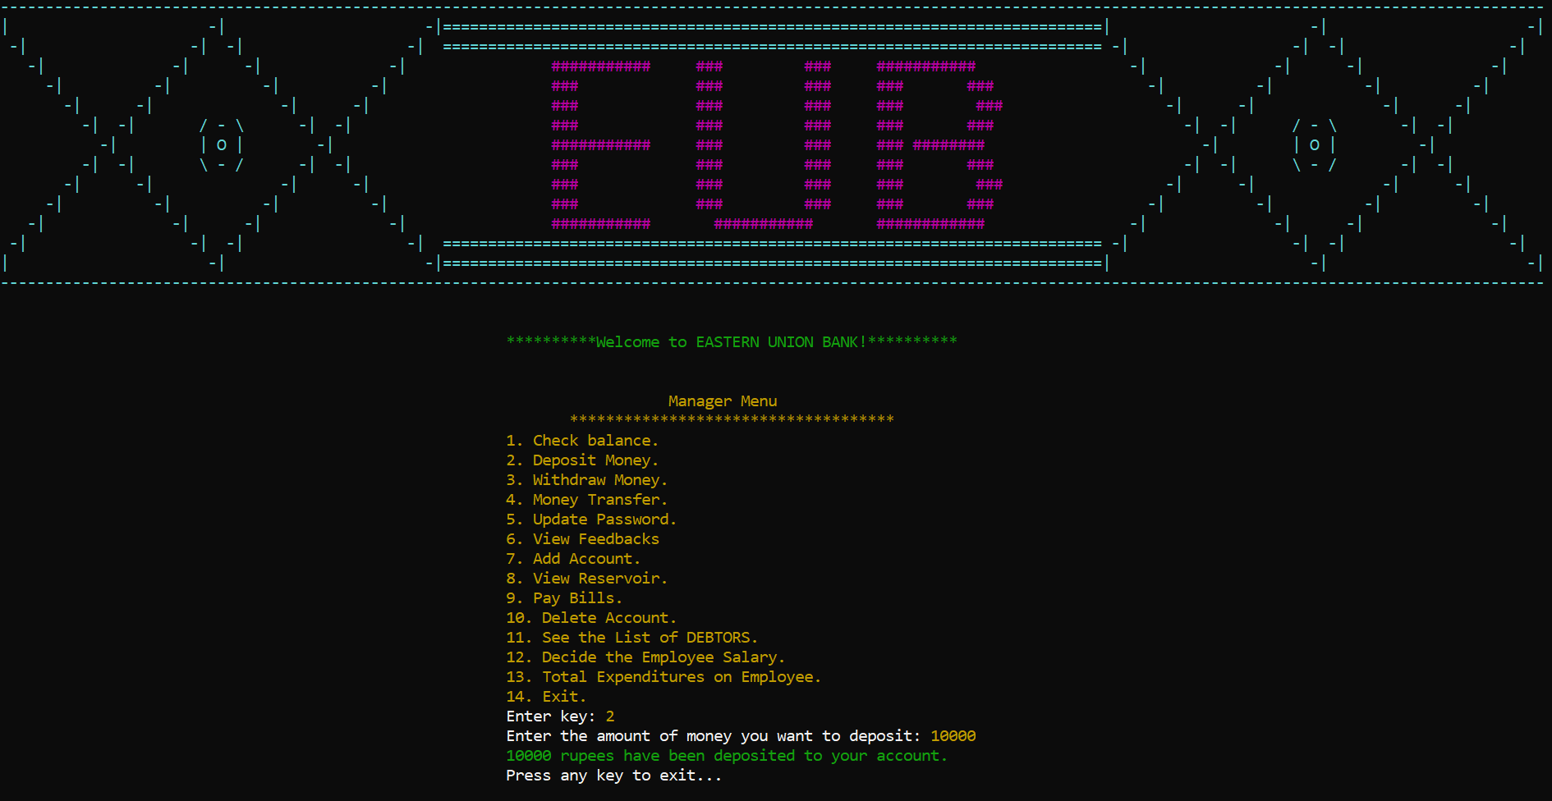

Figure 22. Deposit Money

• Withdraw Money:

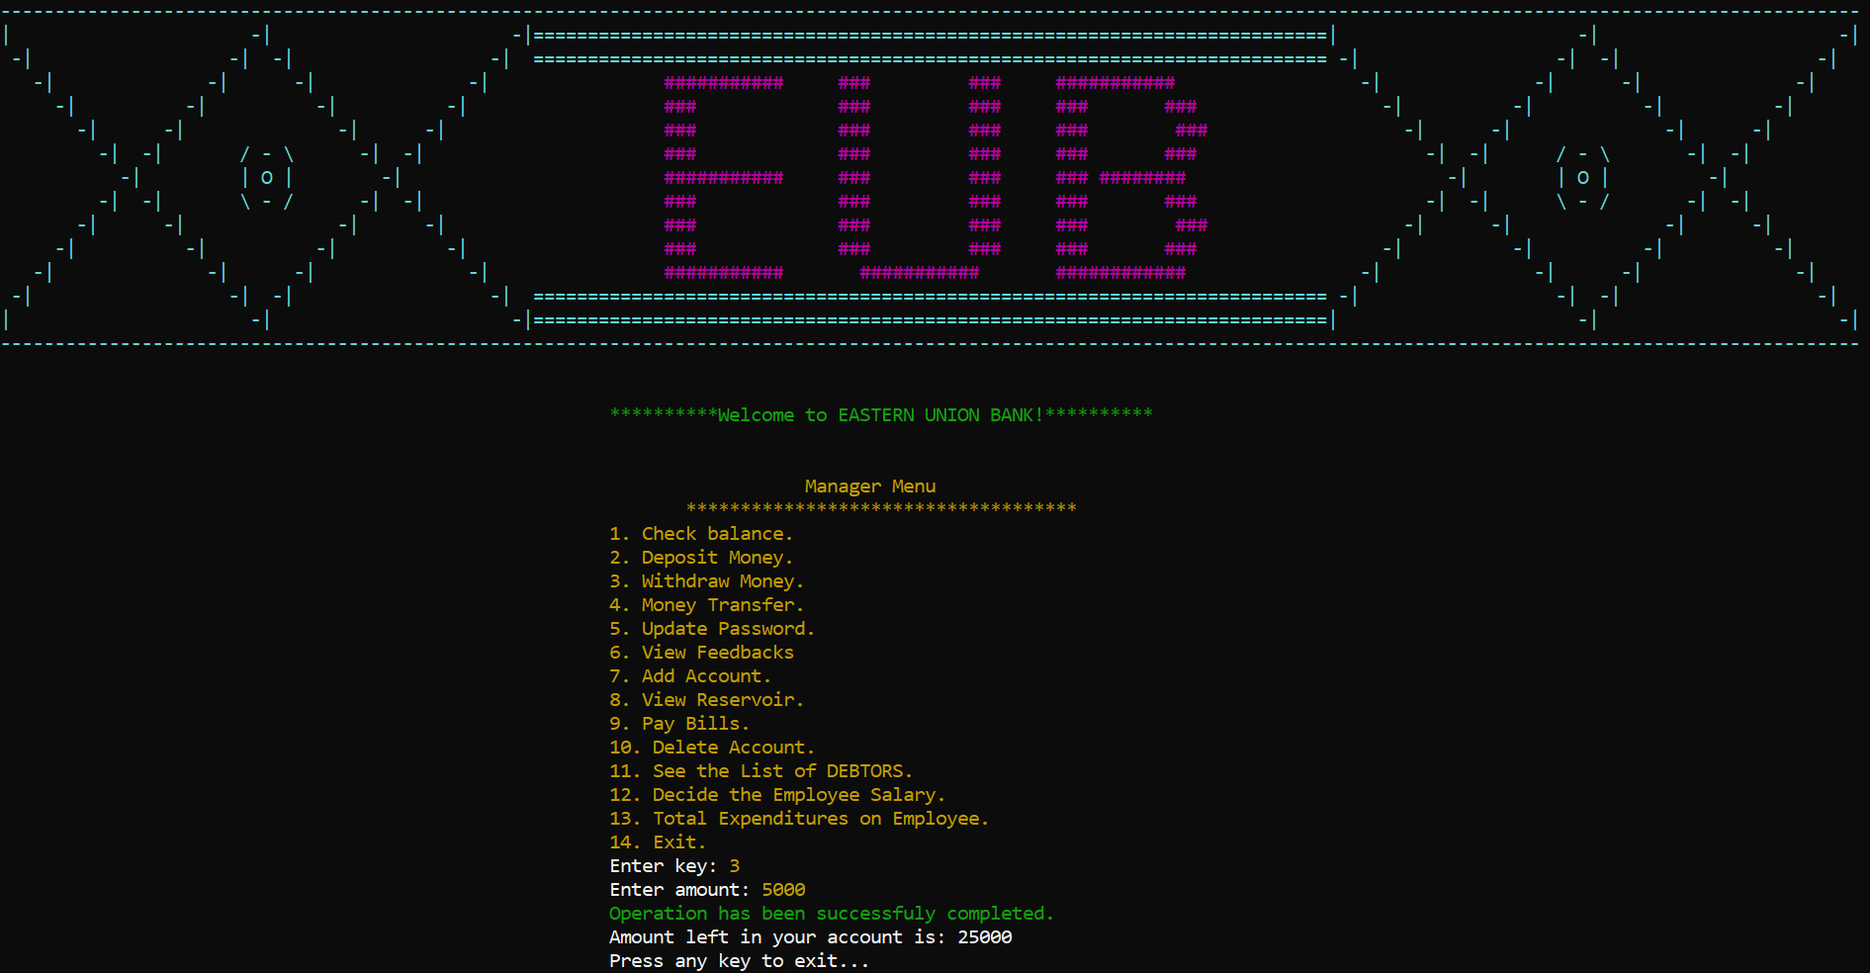

Figure 23. Withdraw Money

• Money Transfer:

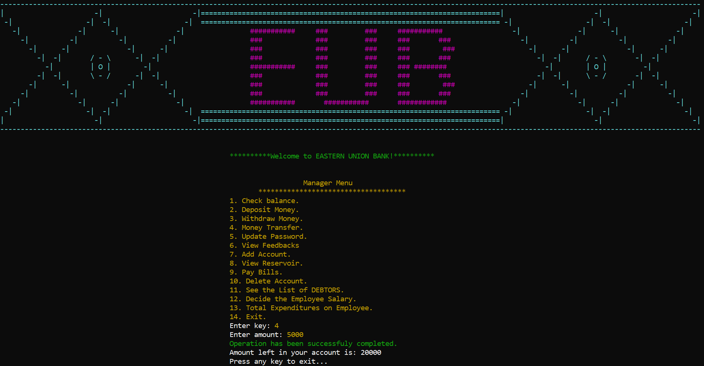

Figure 24. Money Transfer

• Update Password:

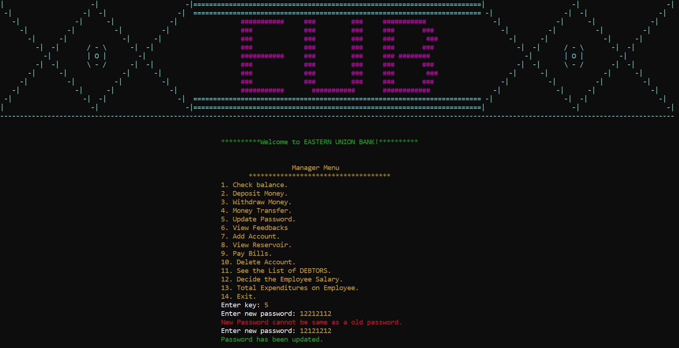

Figure 25. Update Password

• View Feedbacks:

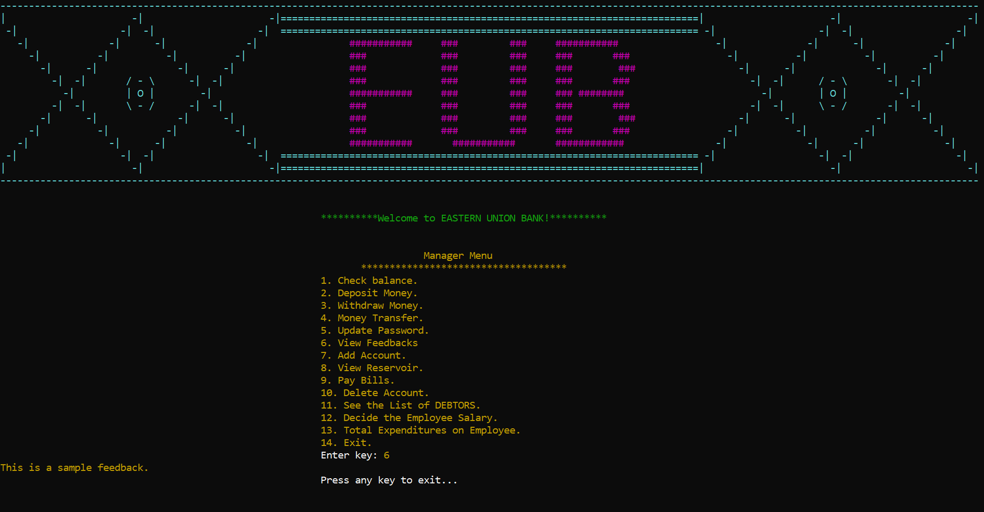

Figure 26. View Feedbacks

• Add Accounts:

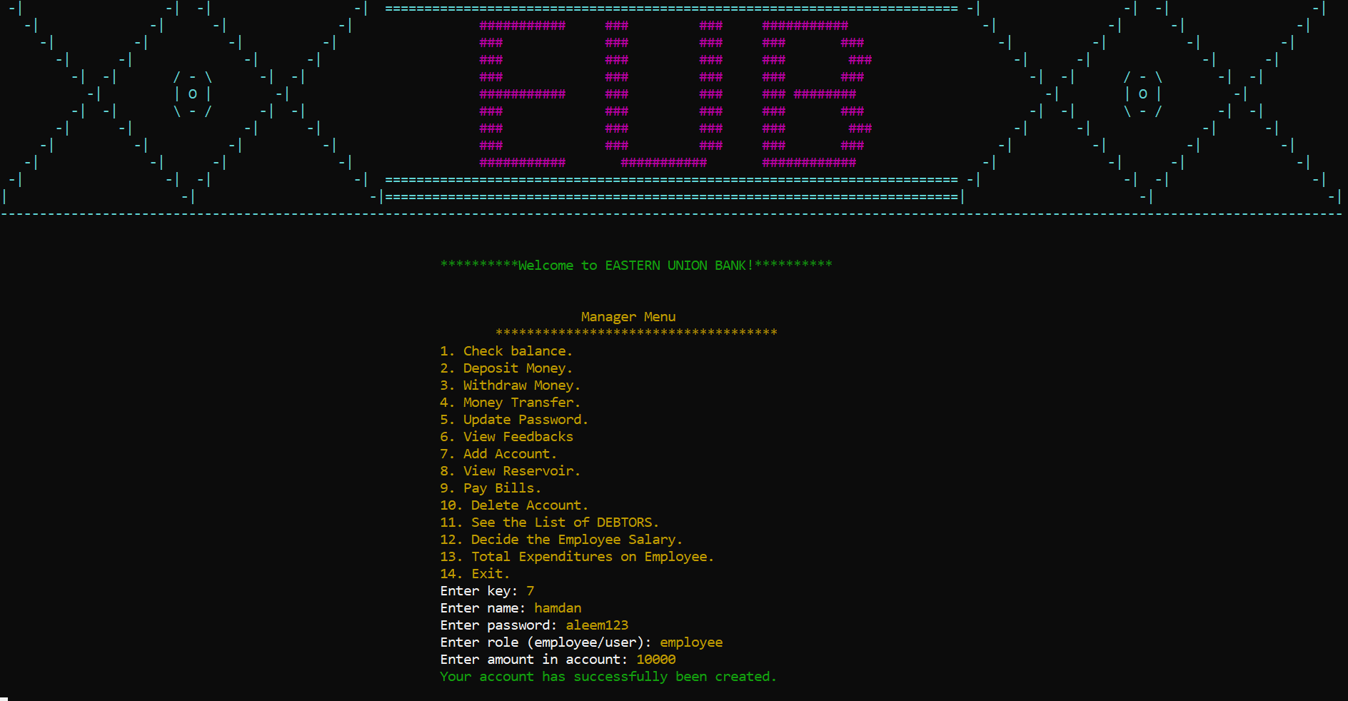

Figure 27. Add Account

• View Feedbacks:



Figure 28. View Reservoir

• Add Accounts:



Figure 29. Add Accounts

• View Reservoir:

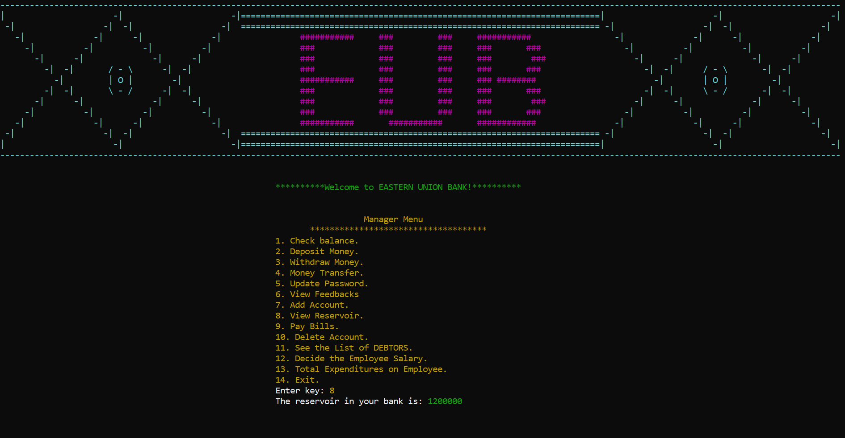

Figure 30. View Reservoir

• Pay Bills Menu:



Figure 31. Pay Bills Menu

• Electricity Bill:



Figure 32. Electricity Bill Menu

• Gas Bill:



Figure 33. Gas Bill Menu

• Water Bill:



Figure 34. Water Bill Menu

• Delete Account:

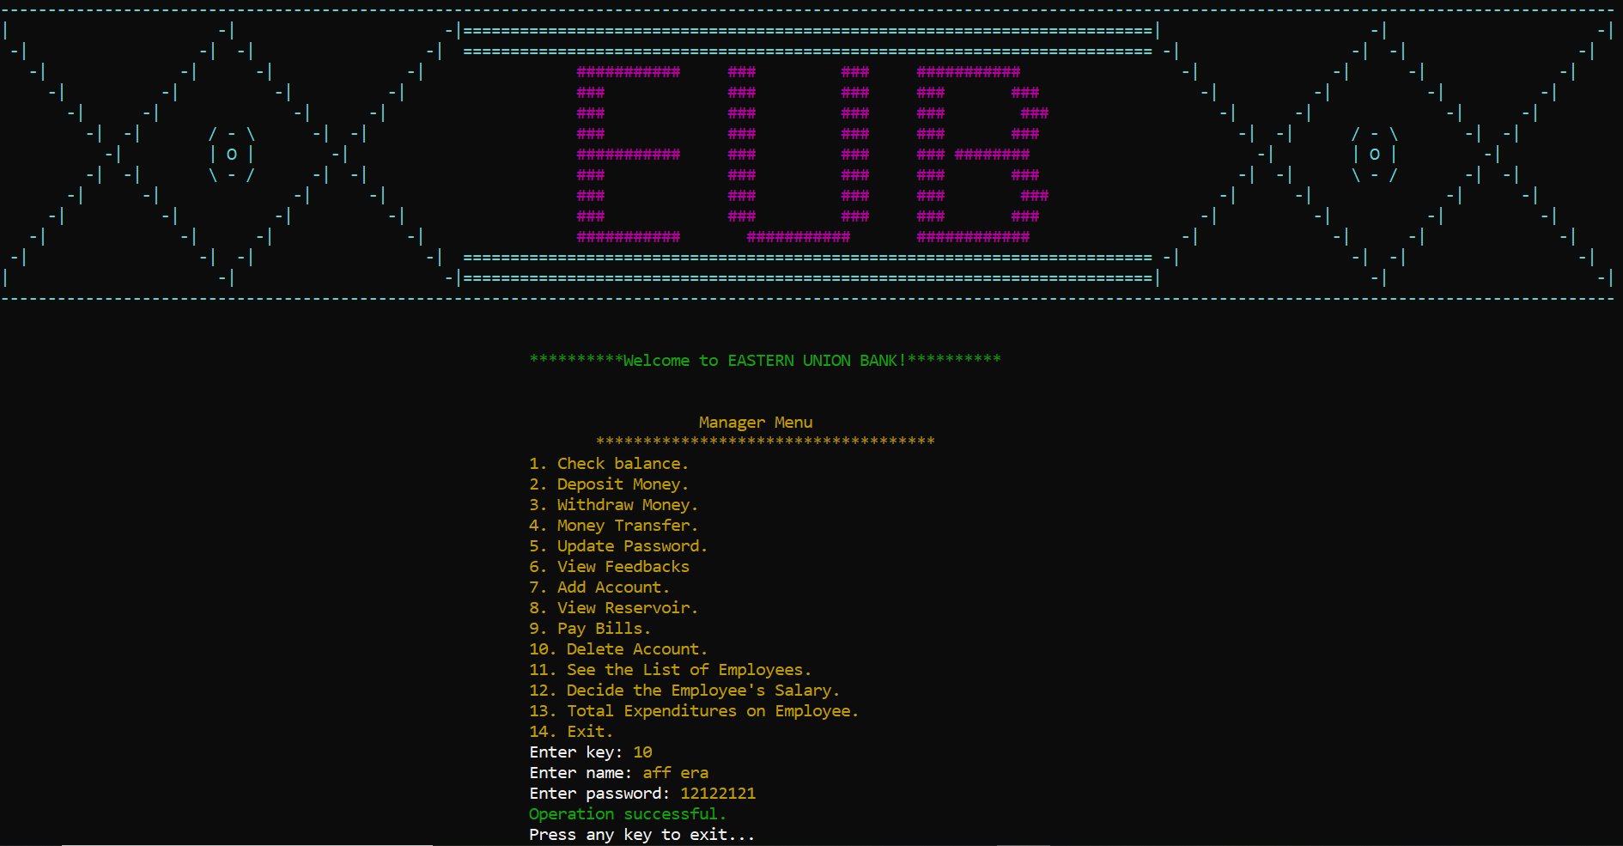

Figure 35. Delete Account

• See the list of employees:

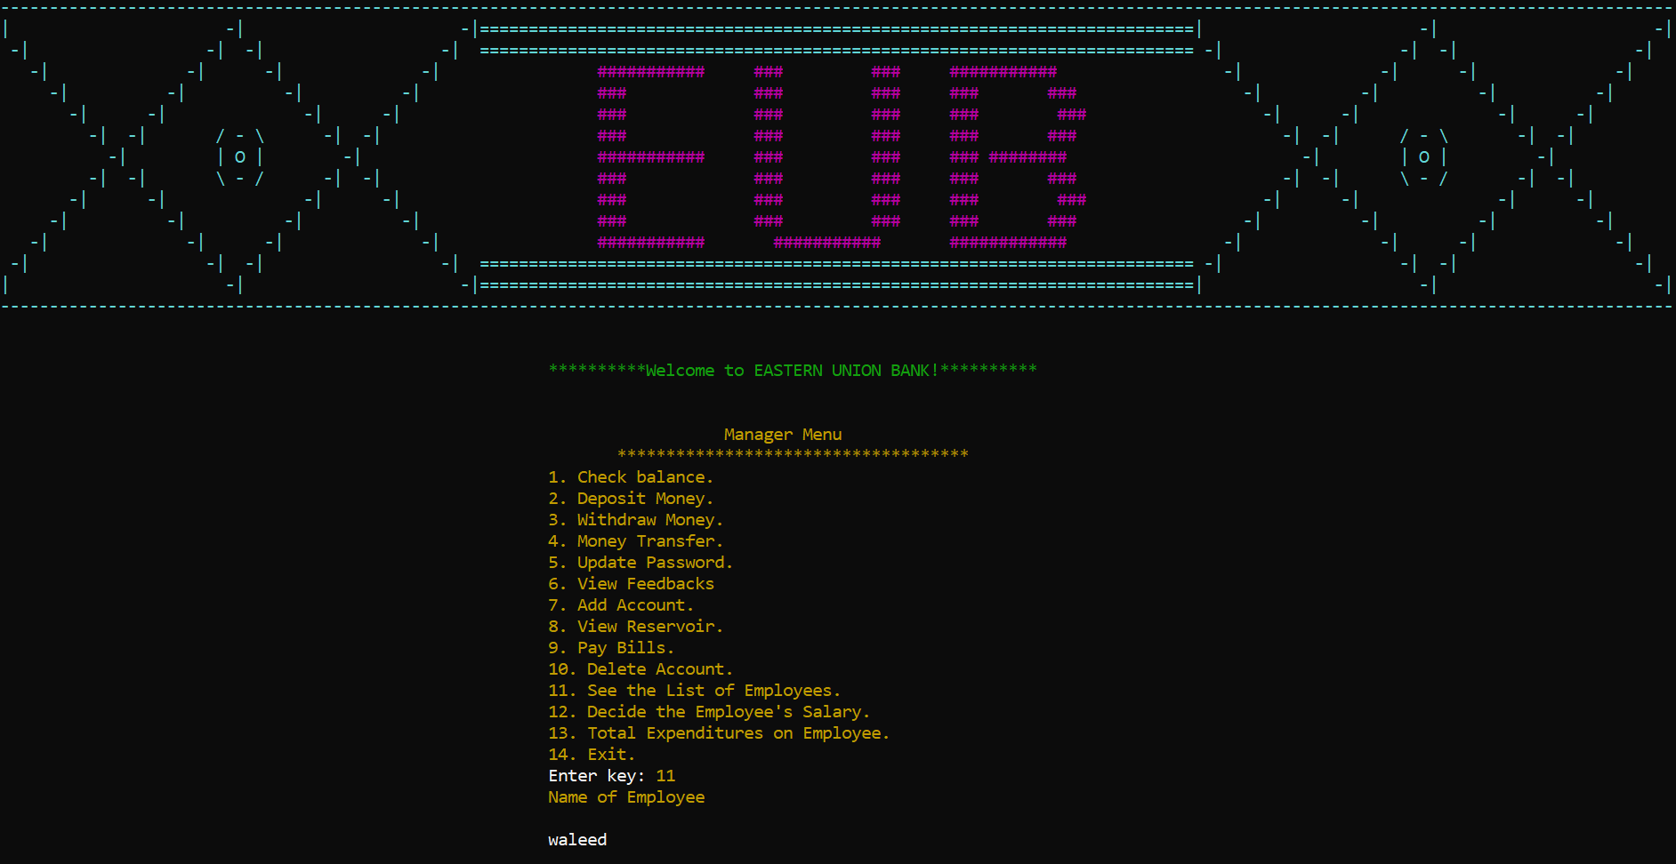

Figure 36. See the list of employees

• Decide Employee’s salary:



Figure 37. Decide Employee’s salary

• Total expenditure on employees:

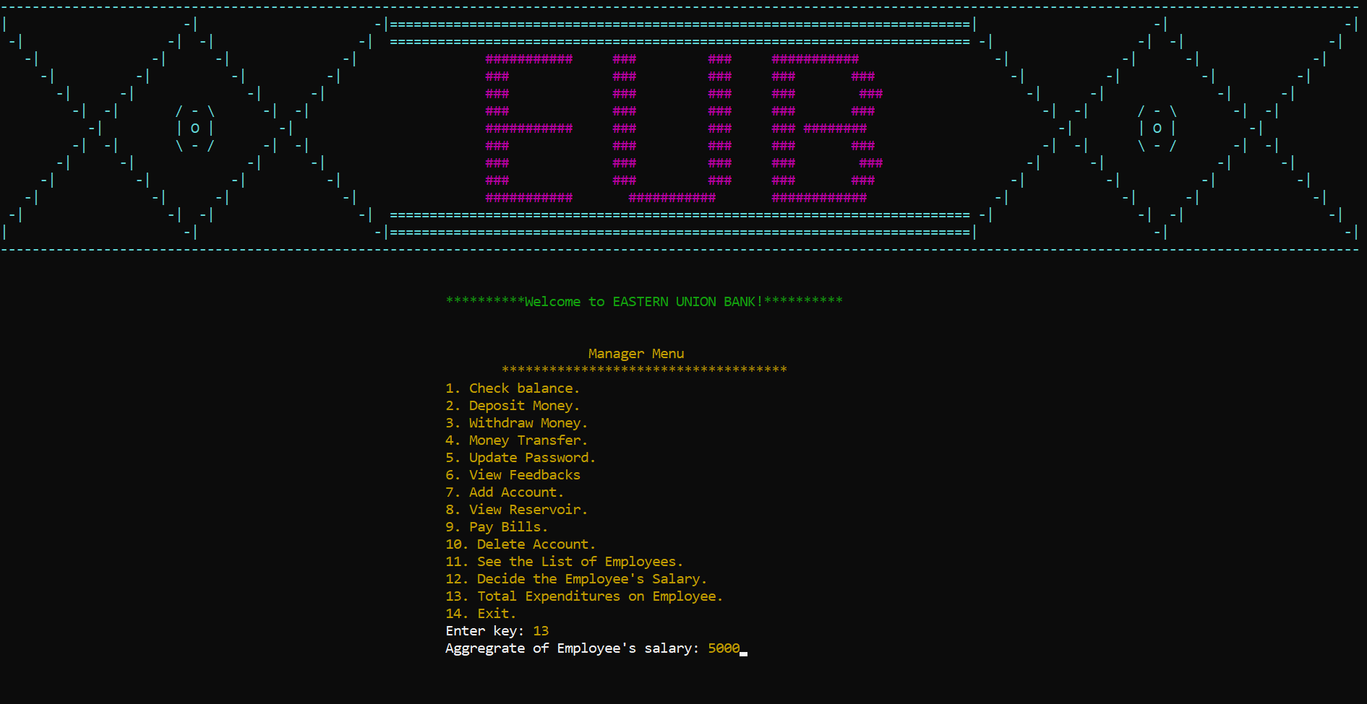

Figure 38. Total Expenditure on employees

User Type (Employee):

• Employee Menu:

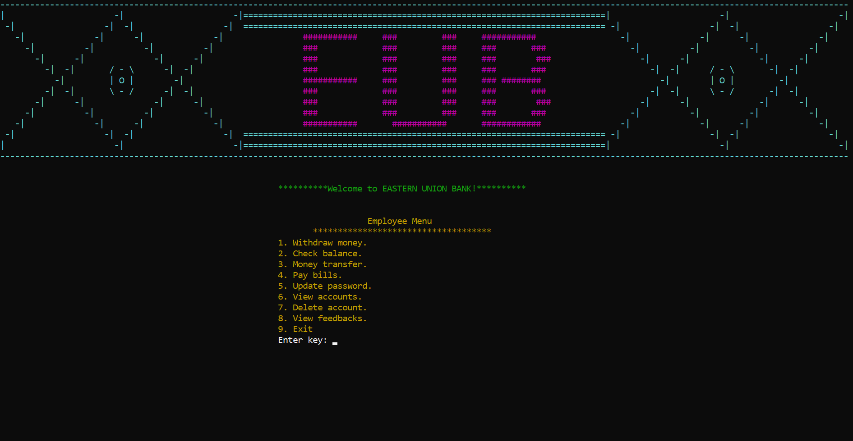

Figure 39. Employee Menu

• Withdraw Money:

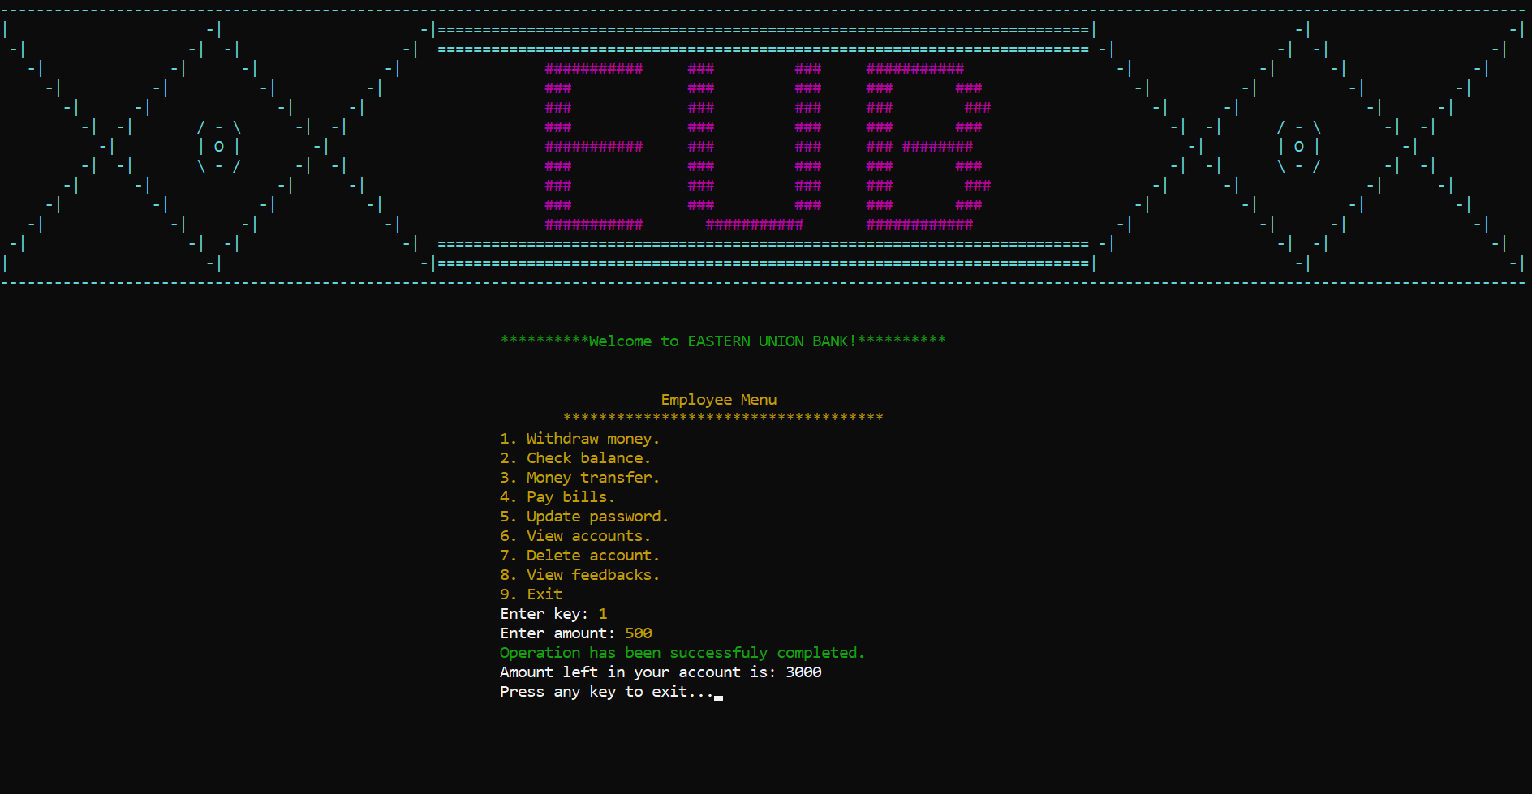

Figure 40. Withdraw Money

• Check Balance:

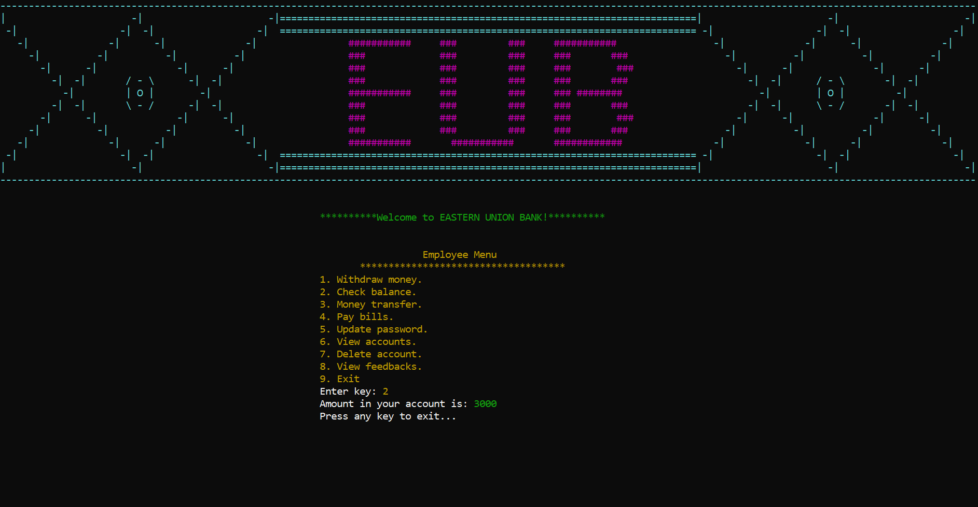

Figure 41. Check Balance

• Money Transfer:

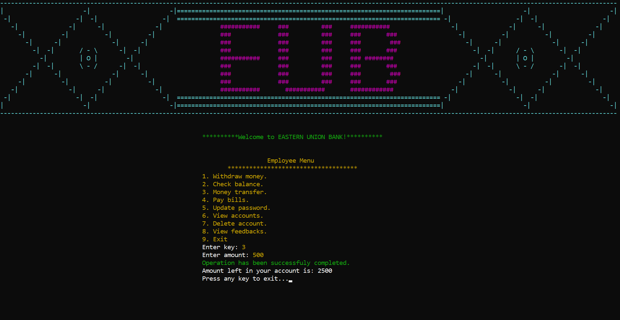

Figure 42. Money Transfer

• Pay Bills Menu:



Figure 43. Pay Bills Menu

• Electricity Bill Menu:



Figure 44. Electricity Bill Menu

• Gas Bill Menu:



Figure 45. Gas Bill Menu

• Water Bill Menu:



Figure 46. Water Bill Menu

• Update Password:

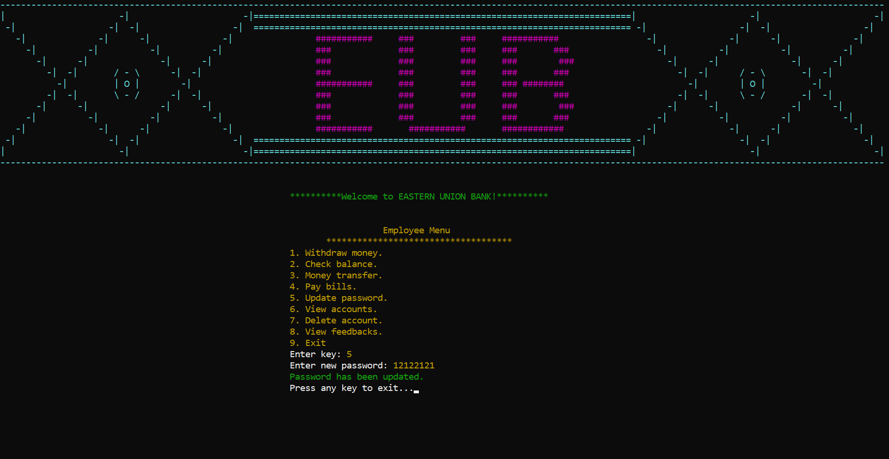

Figure 47. Update Password

• View Accounts:

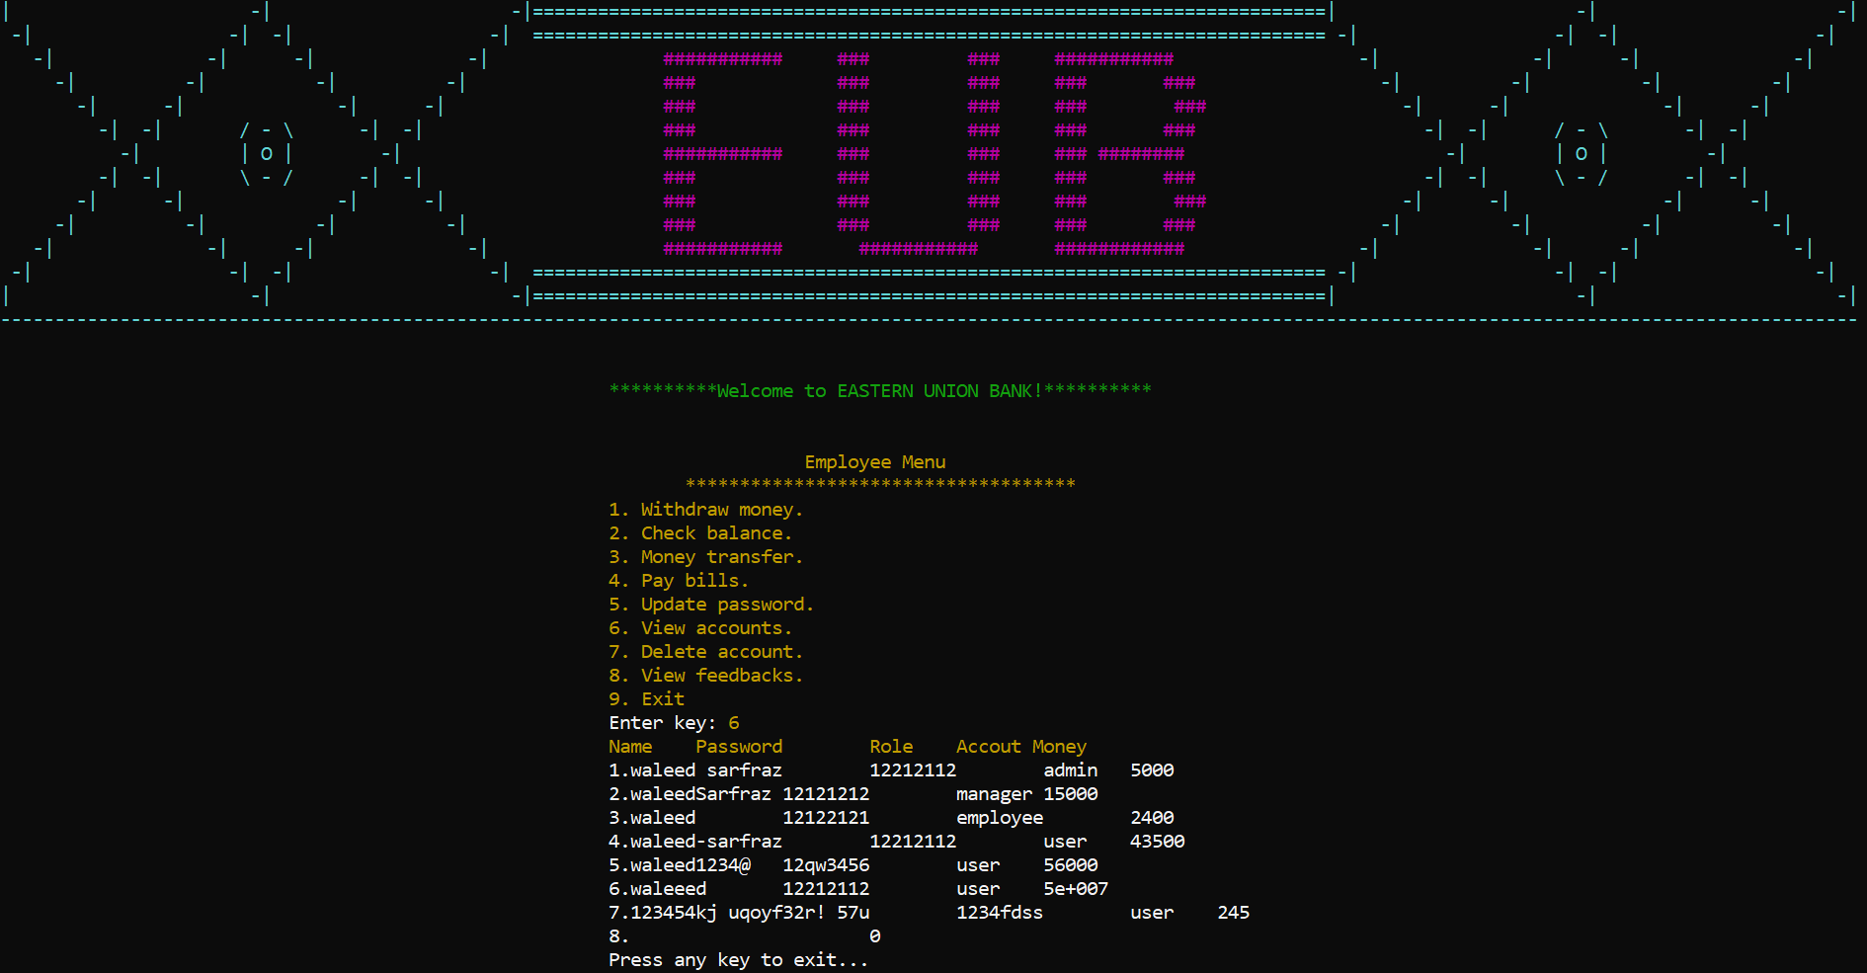

Figure 48. View Accounts

• Delete Account:

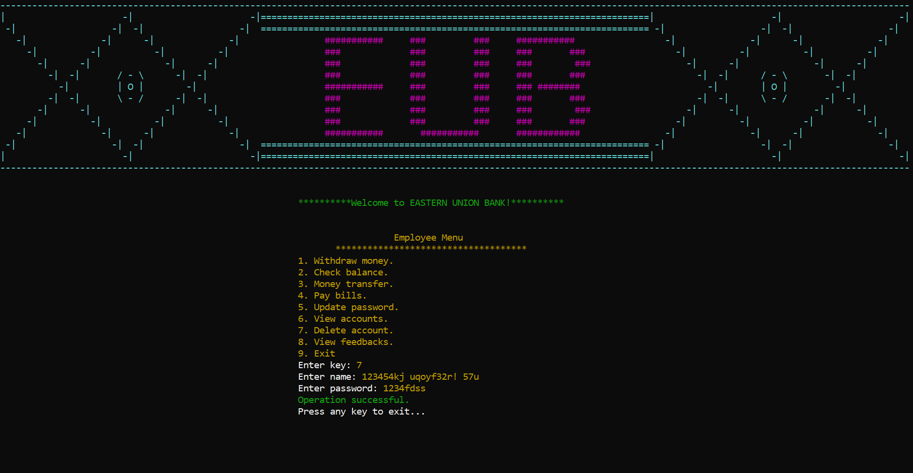

Figure 49. Delete Account

• View Feedbacks:

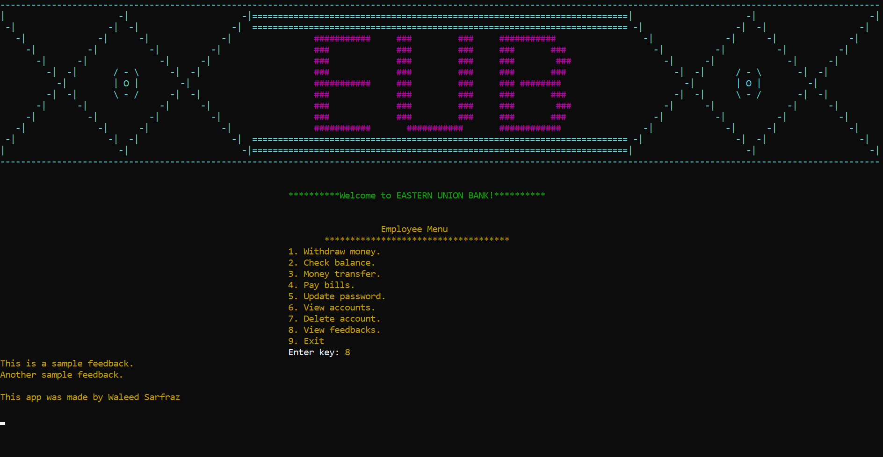

Figure 50. View Feedbacks

User Type (User):

• User Menu:

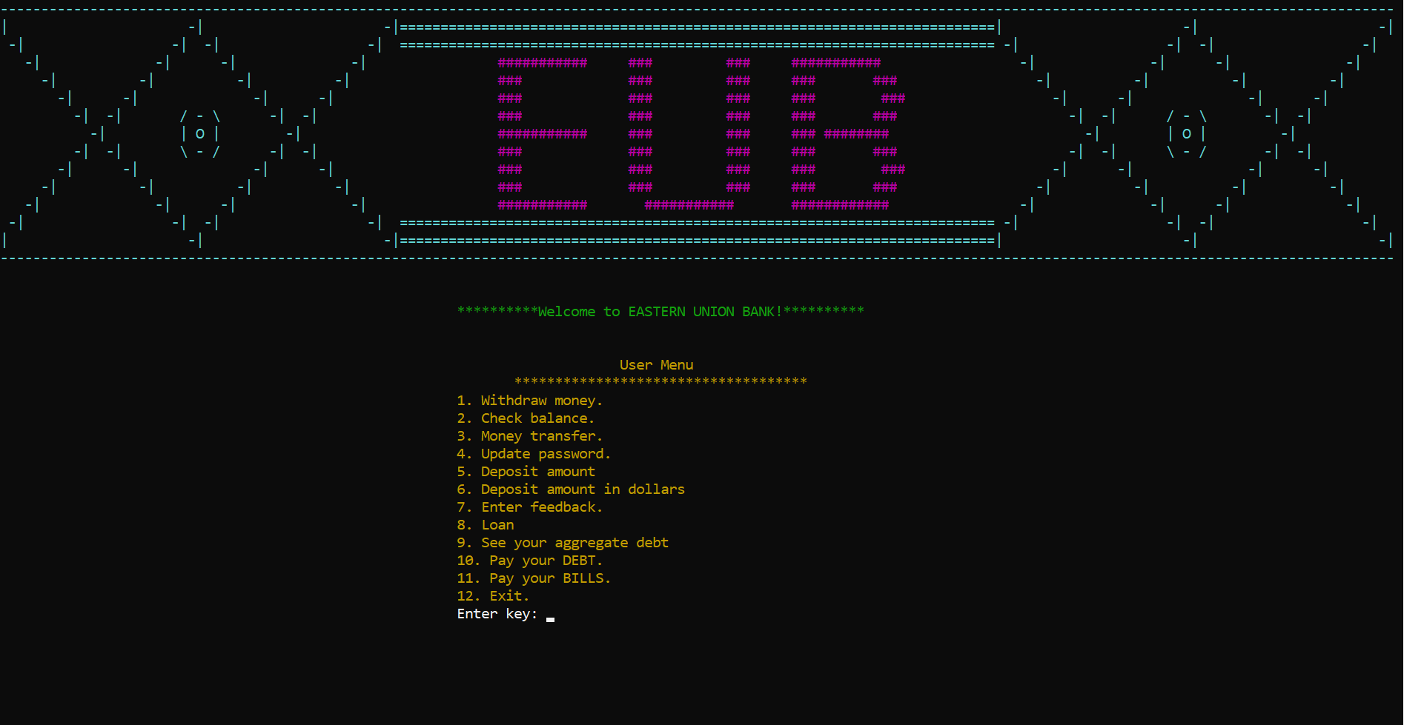

Figure 51. User Menu

• Withdraw money:

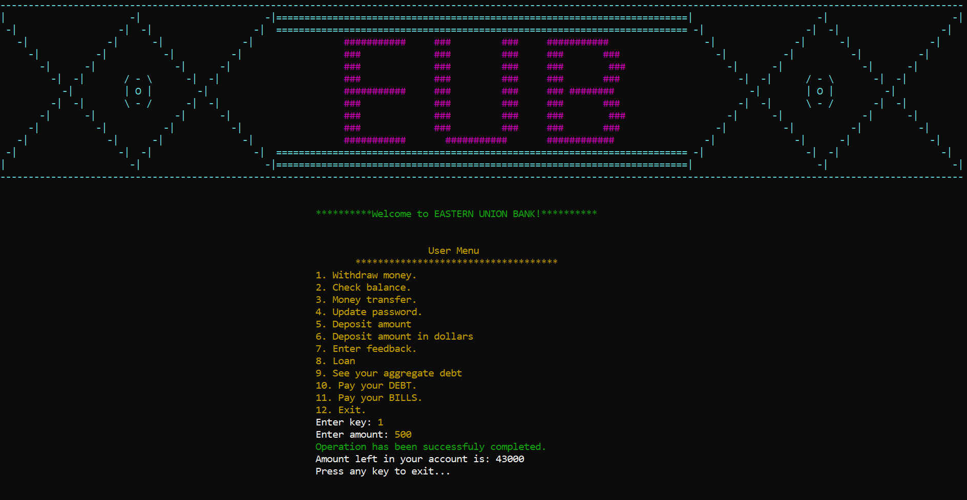

Figure 52. Withdraw money

•Check Balance:
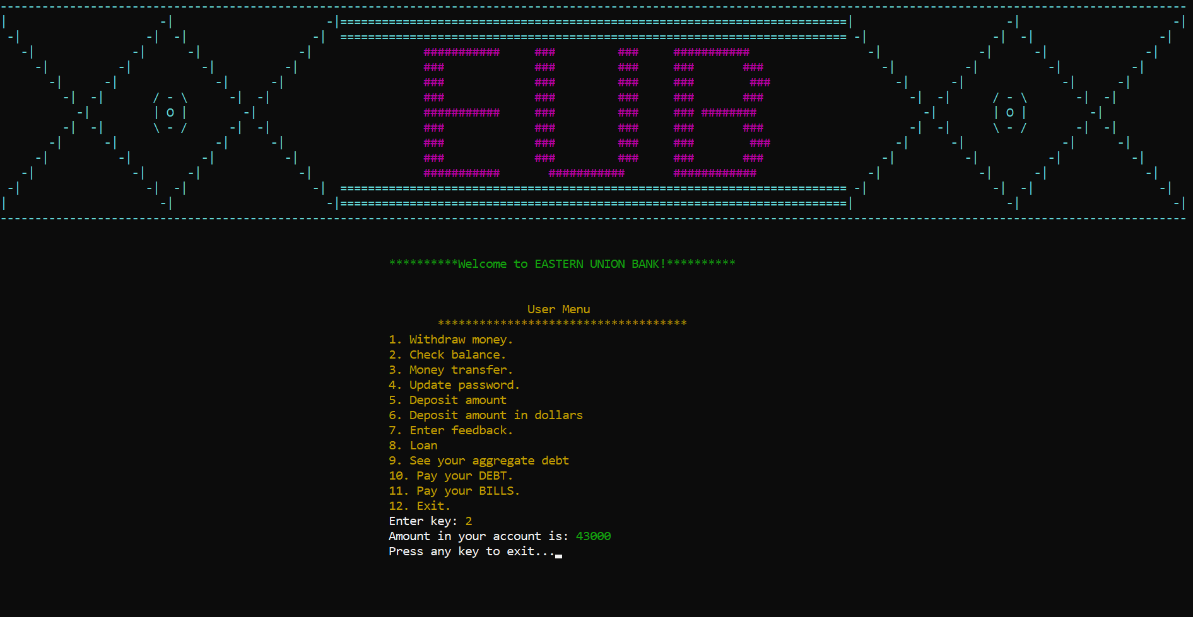

Figure 53. Check Balance

• Money Transfer:



Figure 54. Money Transfer

• Update Password:

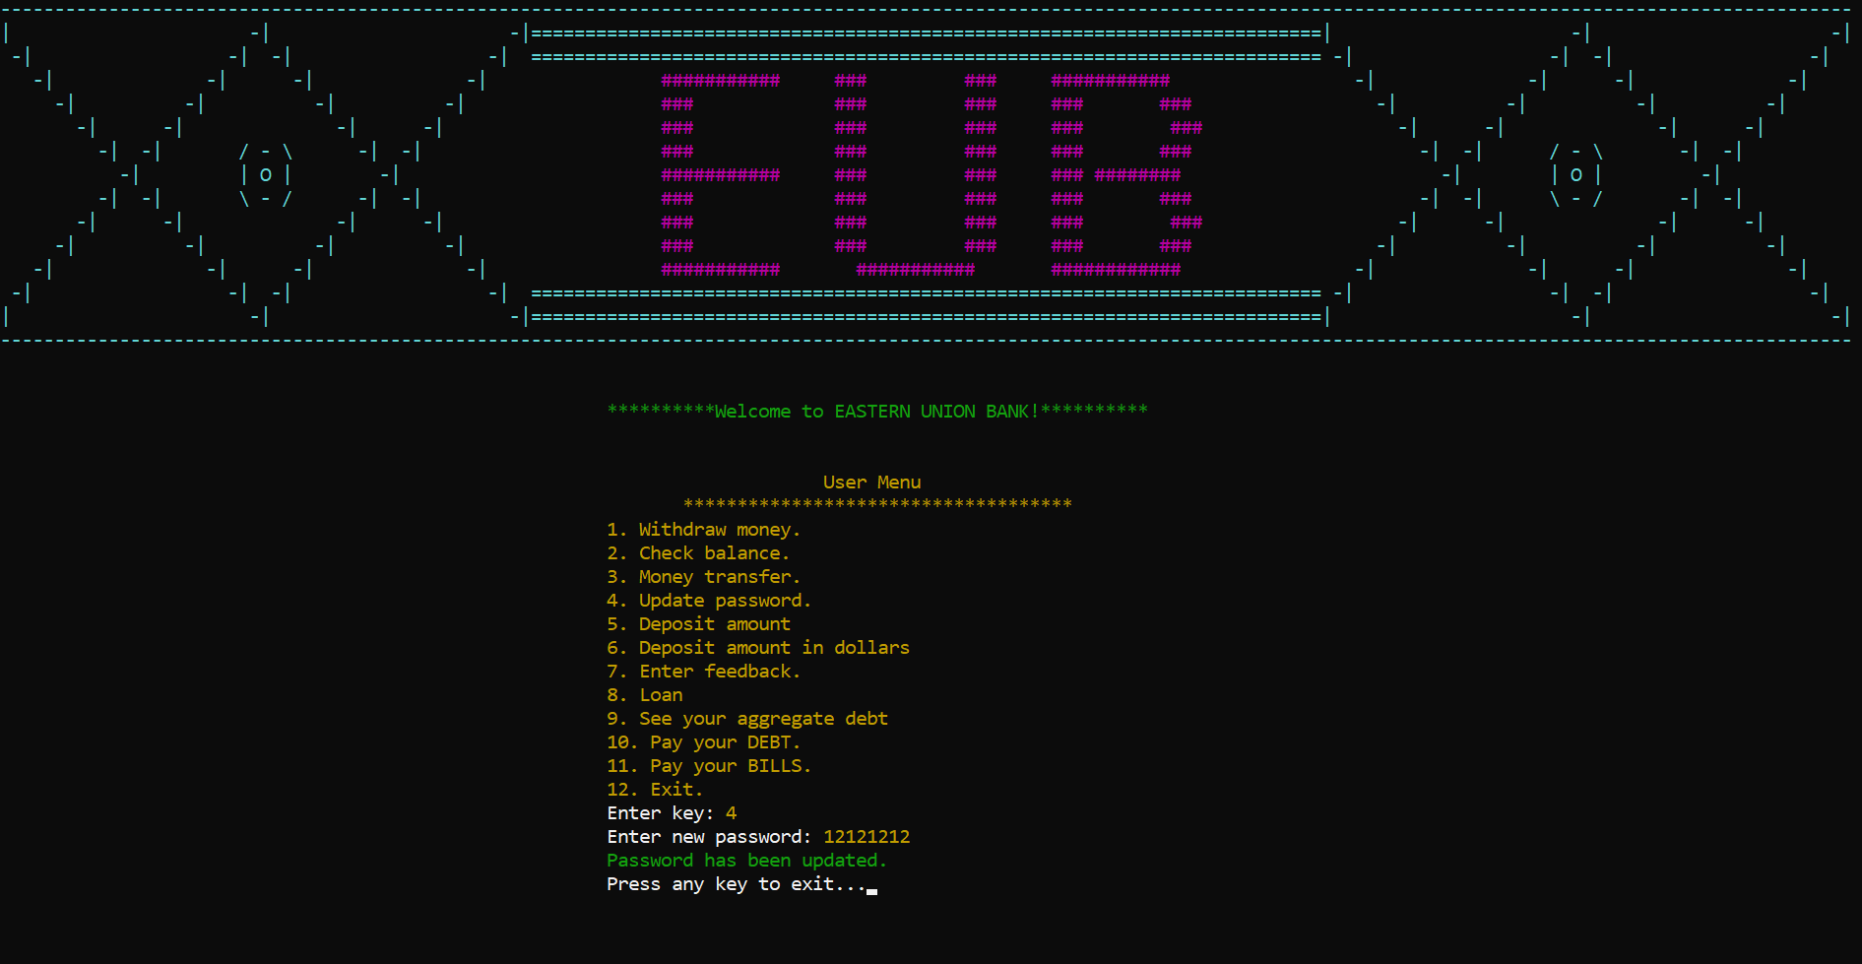

Figure 55. Update Password

• Deposit Amount:

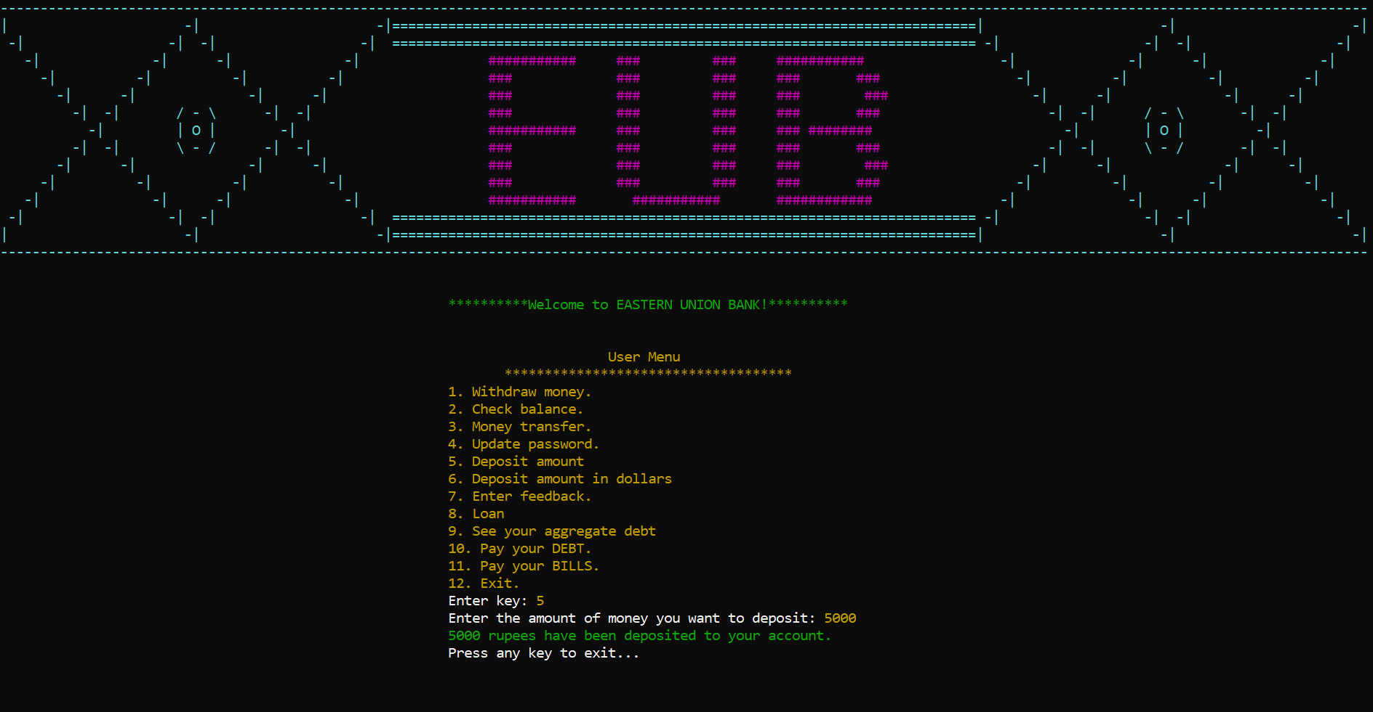

Figure 56. Deposit Amount

• Deposit Amount in Dollars:



Figure 57. Deposit Amount in Dollars

• Enter Feedback:



Figure 58. Enter Feedback

• Update Password:

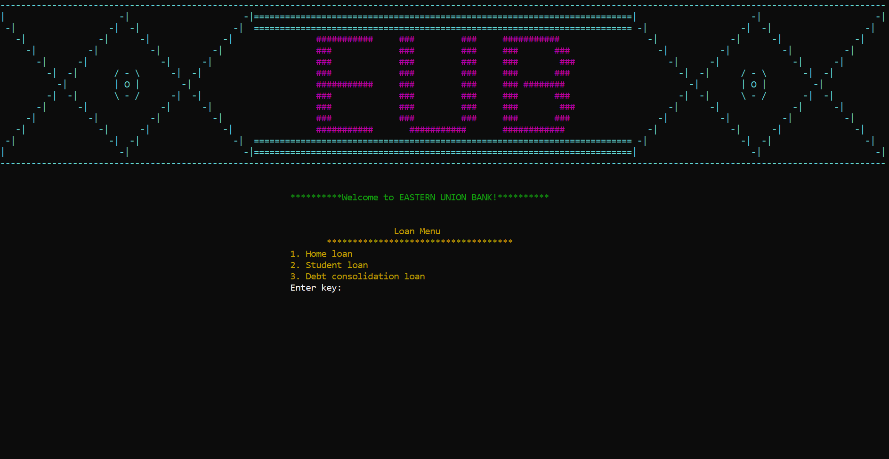

Figure 59. Loan Menu

• Home Loan:

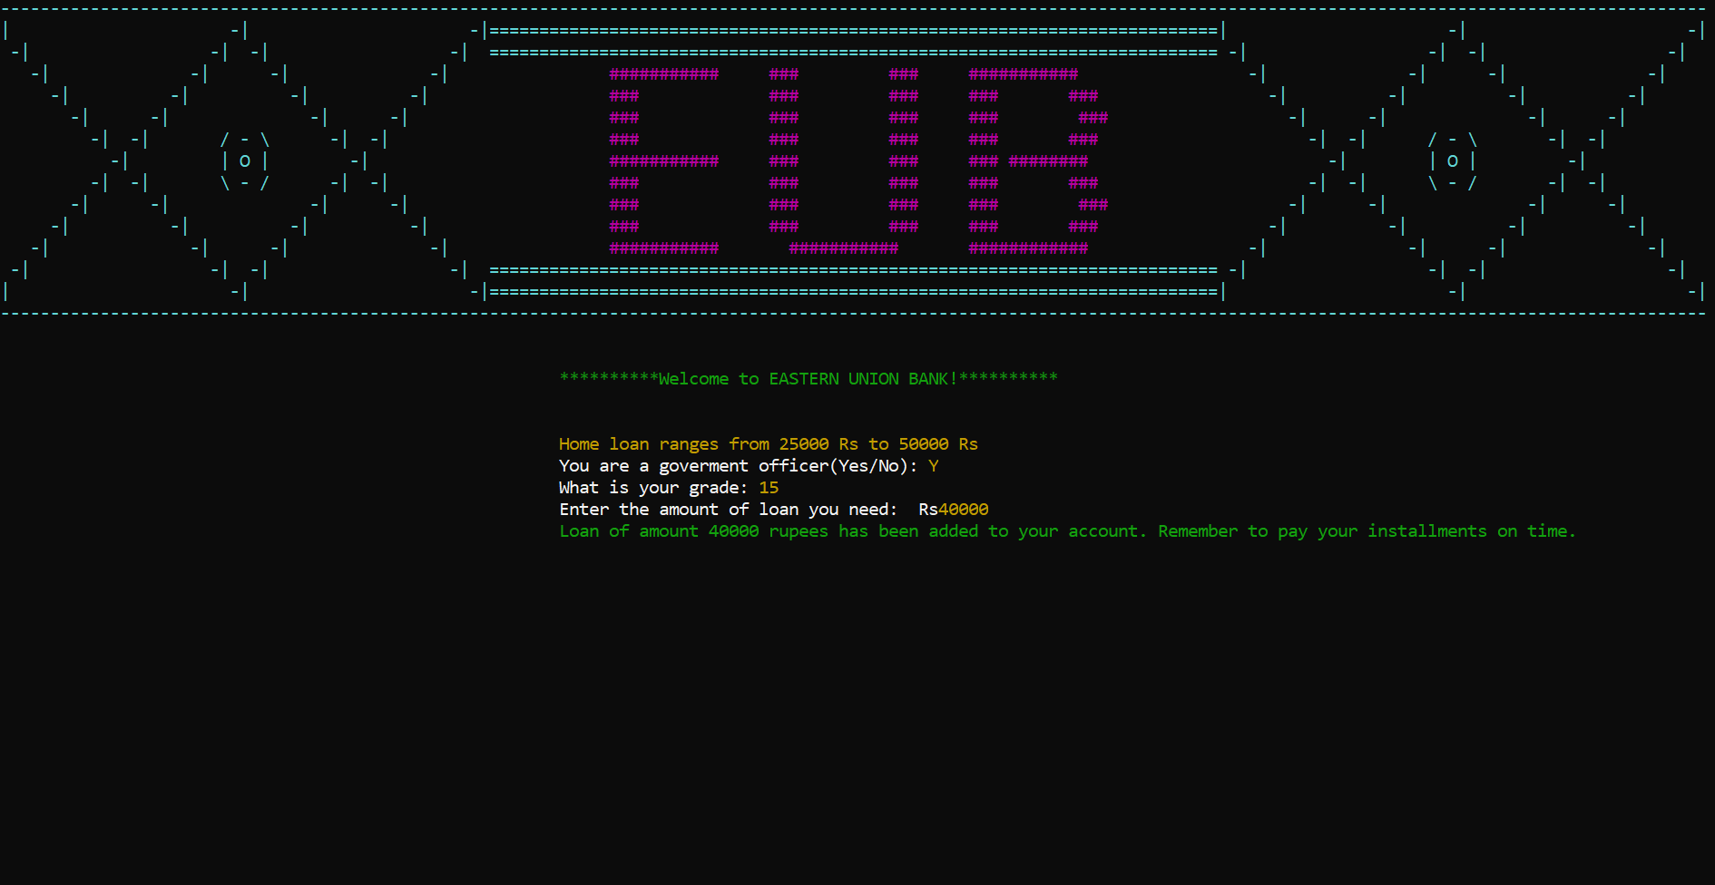

Figure 60. Home Loan

• Student Loan:

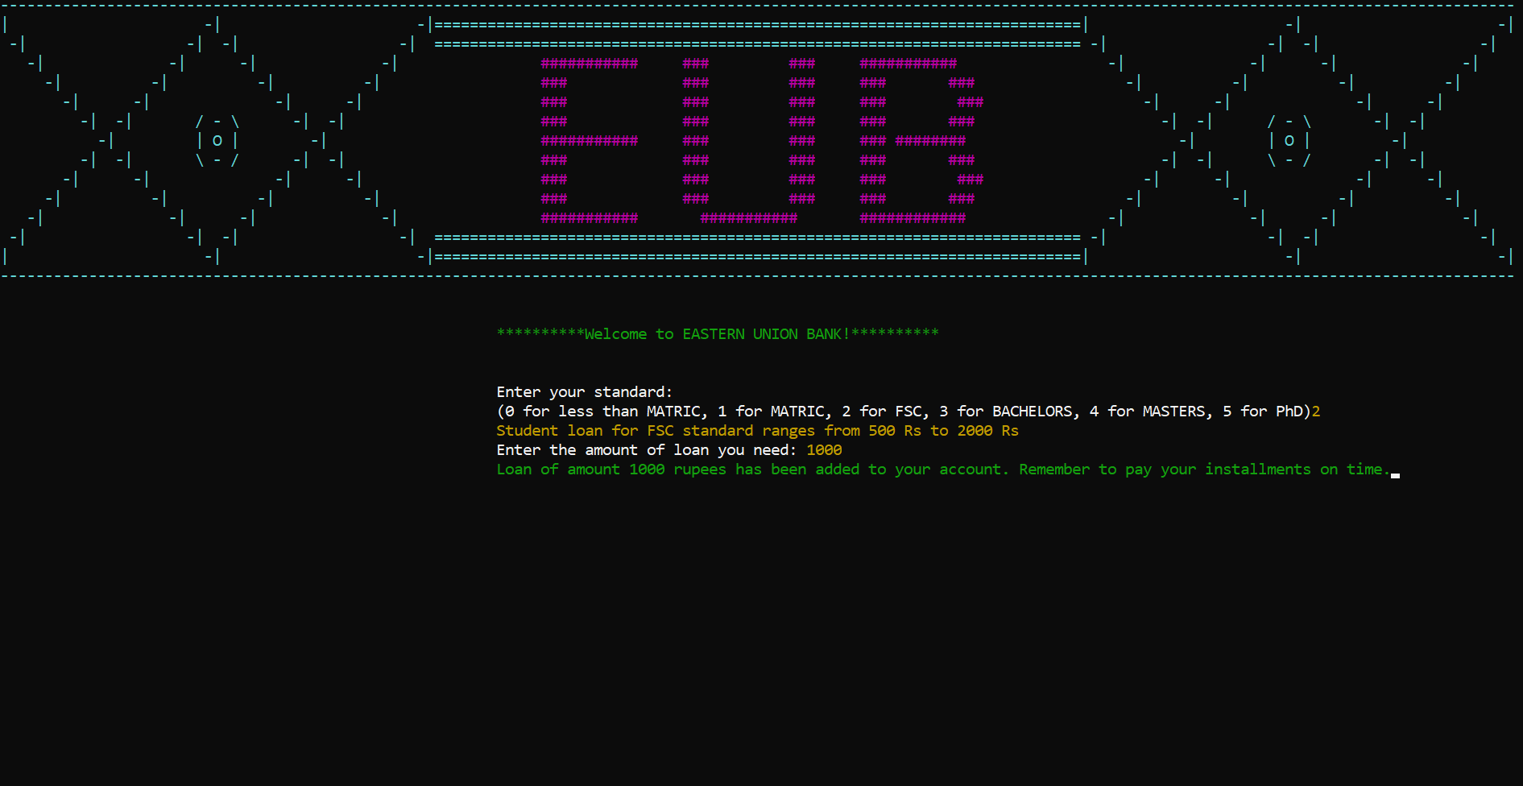

Figure 61. Student Loan

• Debt Consolidation Loan:

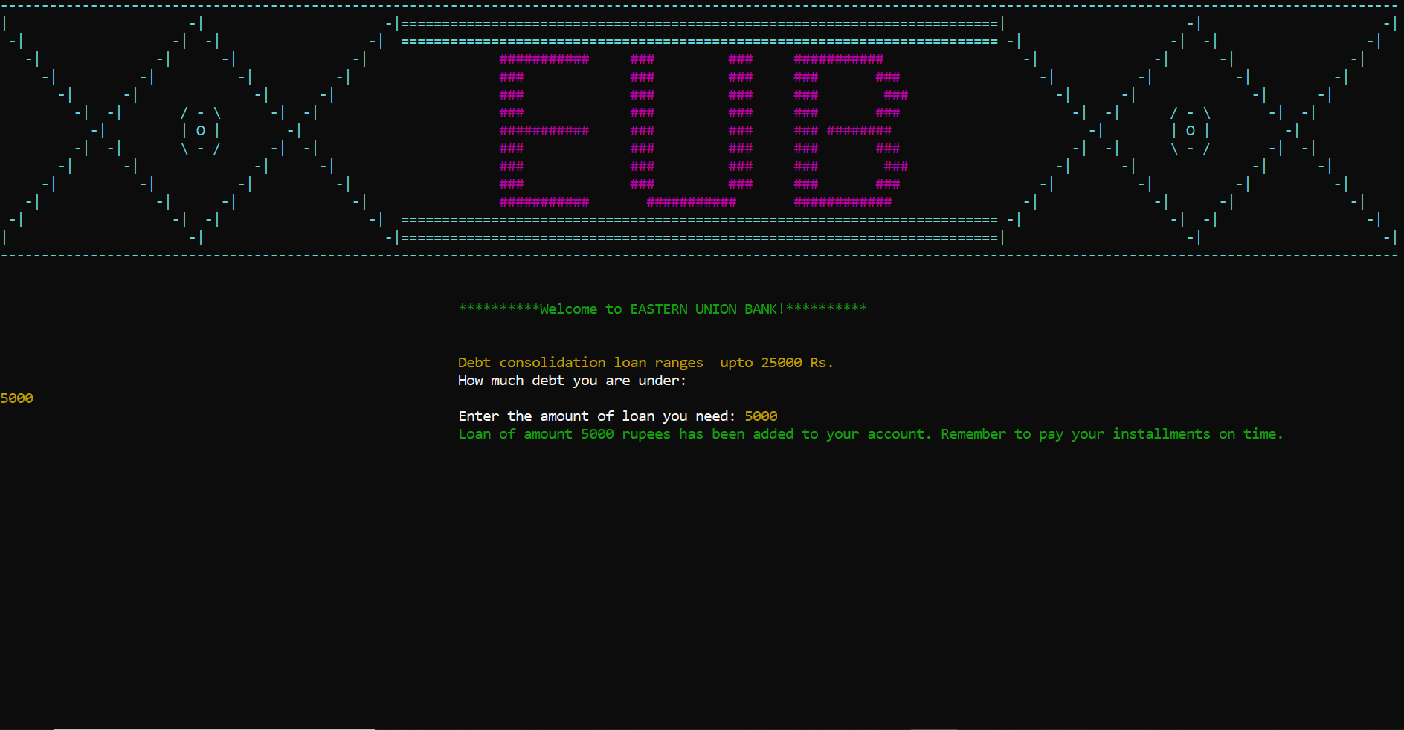

Figure 62. Debt Consolidation Loan

• See Your Aggregate Debt:

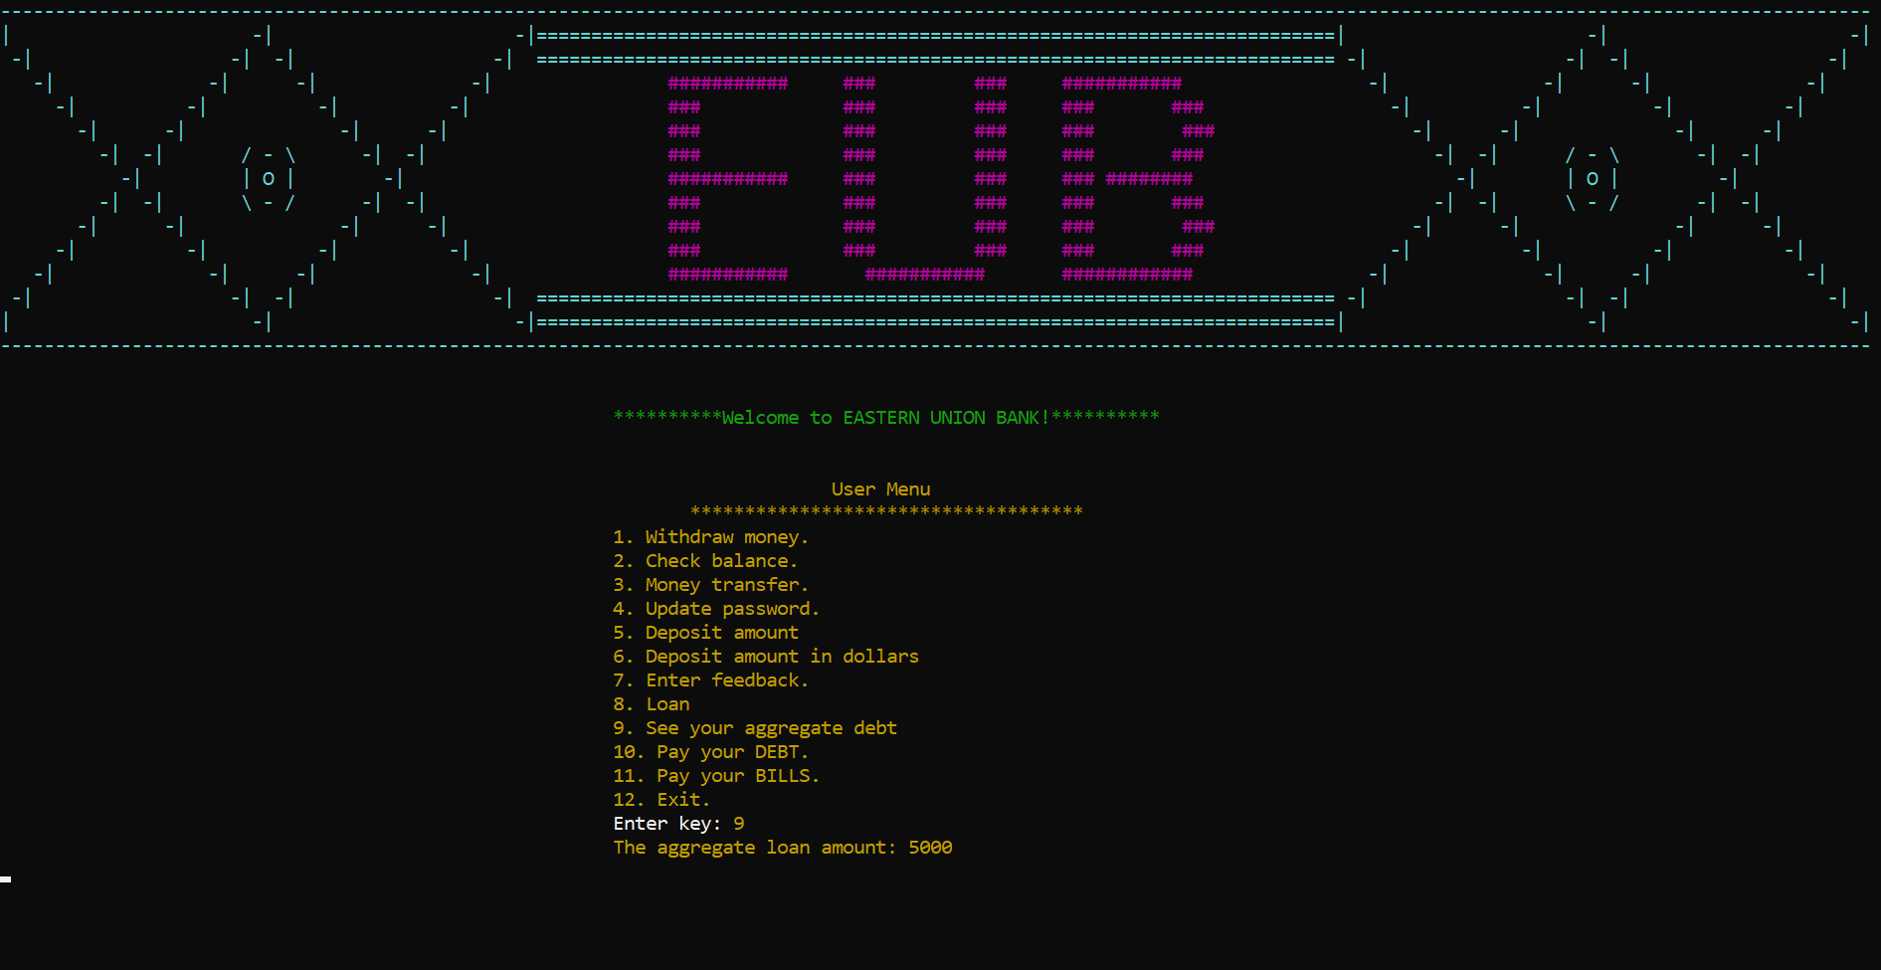

Figure 63. See your aggregate debt

• Pay your Debt:

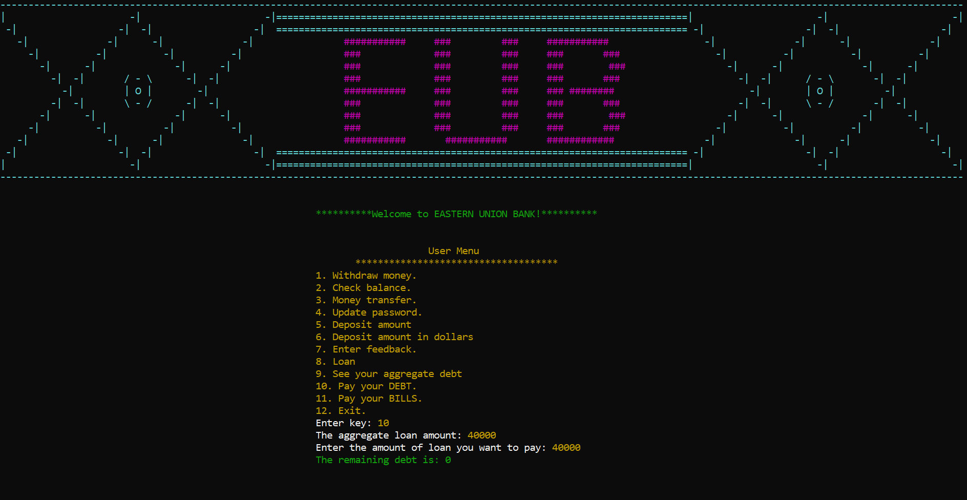

Figure 64. Pay your debt

• Pay Bills Menu:



Figure 65. Pay Bills Menu

• Electricity Bill:



Figure 66. Electricity Bill Menu

• Gas Bill:



Figure 67. Gas Bill Menu

• Water Bill:



Figure 68. Water Bill Menu

Data Structure:
Parallel 1-dimensional array data structure is implied in the current version of Eastern Union Bank. Data storing is organized in an orderly fashion in parallel arrays and there is not a single global variable or array.
- const int sizeOfArray = 10;
- int indexInAlmostAllArrays;
- int selectOption;
- int signupCount = 0;
- int countOfFeedbacks = 0;
- string signInName;
- string signInPassword;
- string nameOfUSer[sizeOfArray];
- string passwordOfUser[sizeOfArray];
- string role[sizeOfArray];
- float accountMoney[sizeOfArray];
- string feedbacks[sizeOfArray];
- int idx=-1;

Flowchart:
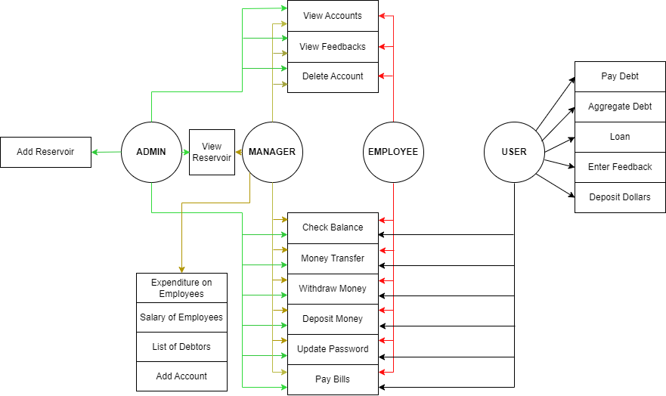

Function Prototypes:
Eastern Union Bank app is made by using almost all the single functioning functions and they are independent of each other. Following are the Function Prototypes Used:
- void printFirstInterface();
- void header1();
- void eub();
- void printHeader();
- void firstInterface();
- void signUp(int &signupCount, string nameOfUSer[], string passwordOfUser[], string role[], float accountMoney[], int &admincount, string &reservoir); // Sign-up function.
- bool checksignIn(int sizeOfArray, string nameOfUSer[], string passwordOfUser[], string signInName, string signInPassword, int &indexInAlmostAllArrays);
- void updatePass(int indexInAlmostAllArrays, int sizeOfArray, string nameOfUSer[], string passwordOfUser[], string signInName, string signInPassword);
- void adminMenu();
- void employeeMenu();
- void userMenu();
- void exit();
- float subtract(float accountMoney, float withdraw);
- void firstOption(float accountMoney[], int indexInAlmostAllArrays);
- void mainSecondOption(int indexInAlmostAllArrays, int sizeOfArray, string nameOfUSer[], string passwordOfUser[], string &signInName, string &signInPassword, string role[], int selectOption, float accountMoney[], int signupCount, string feedbacks[], int &countOfFeedbacks, int idx, int &admincount, string loan[], string &reservoir, string &salaryEmployee);
- float balance(int indexInAlmostAllArrays, float accountMoney[], int sizeOfArray, string nameOfUSer[], string passwordOfUser[], string signInName, string signInPassword);
- void moneyTransfer(int indexInAlmostAllArrays, float accountMoney[]);
- void pasLenSignUp(int signupCount, string passwordOfUser[]);
- void Delete(int &signupCount, string nameOfUSer[], string passwordOfUser[], string role[], float accountMoney[], int &idx, int &admincount, string &reservoir);
- void empDelete(int &signupCount, string nameOfUSer[], string passwordOfUser[], string role[], float accountMoney[], int indexInAlmostAllArrays, int &a);
- void view(int signupCount, string nameOfUSer[], string passwordOfUser[], string role[], float accountMoney[]);
- float currency(int indexInAlmostAllArrays, float accountMoney[], int sizeOfArray, string nameOfUSer[], string passwordOfUser[], string signInName, string signInPassword);
- void feedback(string feedbacks[], int &countOfFeedbacks);
- void showfeed(int countOfFeedbacks, string feedbacks[]);
- void mainSecondAdmin(int selectOption, int sizeOfArray, int &signupCount, string nameOfUSer[], string passwordOfUser[], string role[], float accountMoney[], int indexInAlmostAllArrays, string signInName, string signInPassword, int &countOfFeedbacks, string feedbacks[], int idx, int &admincount, string &reservoir); // Sign-up function.
- void mainSecondManager(int selectOption, int sizeOfArray, int &signupCount, string nameOfUSer[], string passwordOfUser[], string role[], float accountMoney[], int &indexInAlmostAllArrays, string signInName, string signInPassword, int &countOfFeedbacks, string feedbacks[], int idx, int &admincount, string &reservoir, string &salaryEmployee);
- void mainSecondEmployee(int selectOption, int &signupCount, int sizeOfArray, string nameOfUSer[], string passwordOfUser[], string role[], float accountMoney[], int indexInAlmostAllArrays, int &countOfFeedbacks, string feedbacks[], string signInName, string signInPassword, int &admincount, string &reservoir);
- void mainSecondUser(int selectOption, float accountMoney[], int &indexInAlmostAllArrays, int sizeOfArray, string nameOfUSer[], string passwordOfUser[], string signInName, string signInPassword, string feedbacks[], int &countOfFeedbacks, string loan[], string &reservoir, int signupCount, string role[], int admincount);
- void deposit(int indexInAlmostAllArrays, float accountMoney[]);
- string loan1();
- void homeLoan(int signUpCount, string loan[], float accountMoney[], string &reservoir, int admincount, int signupCount, string nameOfUSer[], string passwordOfUser[], string role[]);
- void studentLoan(int signUpCount, string loan[], float accountMoney[], string &reservoir, int admincount, int signupCount, string nameOfUSer[], string passwordOfUser[], string role[]);
- void debtConsolidationloan(int signUpCount, string loan[], float accountMoney[], string &reservoir, int admincount, int signupCount, string nameOfUSer[], string passwordOfUser[], string role[]);
- bool name_space(string input);
- bool onlyenter(string string);
- bool password_space(string input);
- void seeLoan(string Loan[], int signupCount);
- void payLoan(string loan[], int signupCount, string &reservoir, float accountMoney[], int admincount);
- string payBill();
- void waterBill(float accountMoney[], int indexInAlmostAllArrays);
- void electricityBill(float accountMoney[], int indexInAlmostAllArrays);
- void gasBill(float accountMoney[], int indexInAlmostAllArrays);
- void seeEmployeeList(int signupCount, string role[], string nameOfUSer[]);
- void signUpByManager(int &signupCount, string nameOfUSer[], string passwordOfUser[], string role[], float accountMoney[], int &admincount, string &reservoir); // Sign-up function.
- string getField(string record, int field);
- void storeSignUpOption(string nameOfUSer[], string passwordOfUser[], string role[], float accountMoney[], int signupCount);
- void storeReservoir(string reservoir, int admincount);
- void storeLoan(string loan[], int signupCount);
- void storeFeedback(string feedbacks[], int &countOfFeedbacks);
- void storeSalaryEmployee(string salaryEmployee);
- void readReservoir(string &reservoir, int &admincount);
- void readLoan(string loan[], int signupCount);
- void readSignUpOption(string nameOfUSer[], string passwordOfUser[], string role[], float accountMoney[], int &signupCount);
- void readFeedback(string feedbacks[], int &countOfFeedbacks);
- void readSalaryEmployee(string salaryEmployee);
- // bool variables
- bool checkintstring(string num);
- bool checkUpPass(int signupCount, string arr[], string pass);
- bool check_int(string check);
- HANDLE h = GetStdHandle(STD_OUTPUT_HANDLE);
- void gotoxy(int x, int y); // To print statement at a specific location

Weakness:
Weakness of my project is that our bank reservoir depends only on admin. If admin doesn’t add any money to the bank, no one will be able to take loan. Moreover, only water, electricity and gas bills can be paid through our app, no any other loans.

Future Directions:
Add GUI to this app and try to make this app using OOP and other higher concepts.

